JI-NUIAL IN I tKNAI IUNAL PUBLICATION OF THE

ASSOCIATED LOCKSMITHS OF AMERICA

**Volume 45, Issue 5**

From mystery safes, to lubrication techniques, to product reviews, we take* a look at the world of safes...

f /* ...inside and out,

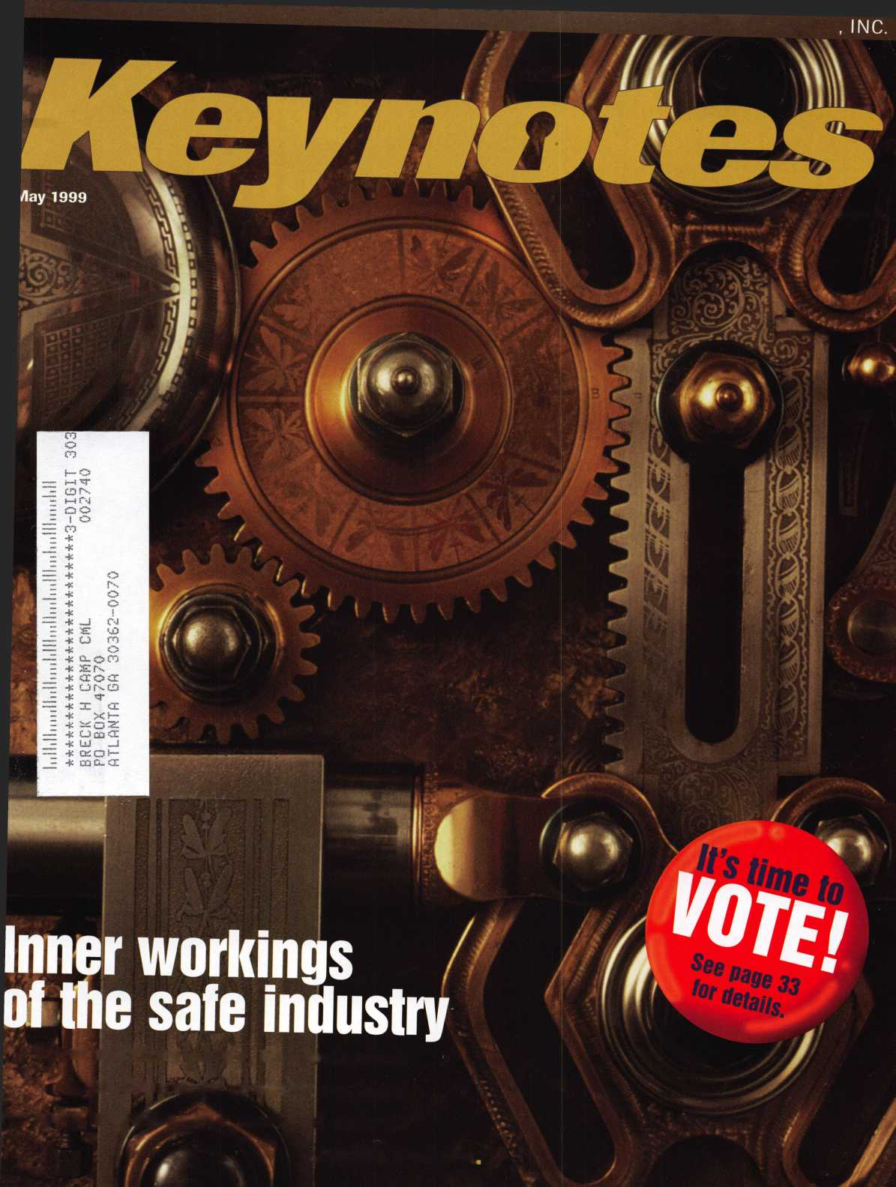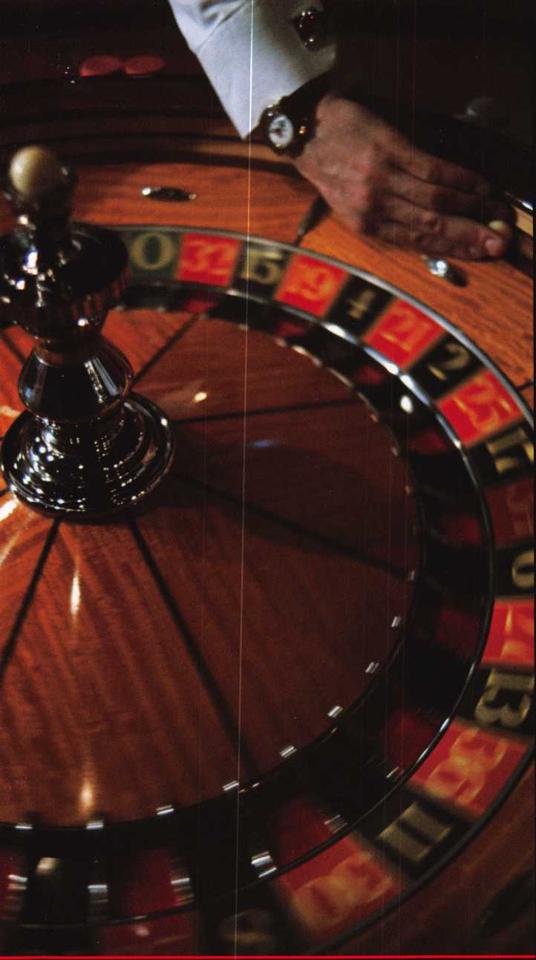

f

You wouldn’t dream of leaving your success  
to chance. You know that making it in the safe  
and vault industry requires hard work, continual  
improvement of techniques, and constant research  
of the latest products and tools.

Your best bet to excel in all these areas is  
SAFETECH ’99 where you can save your luck for  
the casinos, and get down to business viewing  
the latest products, talking with the manufacturers,  
and training in the latest methods of

safe and vault technology.

Make your plans now to attend  
SAFETECH ’99 May 3-8, 1999  
in Las Vegas, NV.

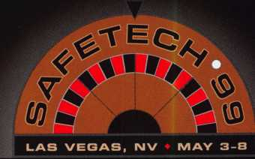

Contact:

Safe and Vault Technicians Association

3003 Live Oak Street Dallas, TX 75204 214.827.7233 214.827.1810 fax email: [convtion@anet-dfw.com](mailto:convtion@anet-dfw.com)

**There is nothing**

ORIGINAL

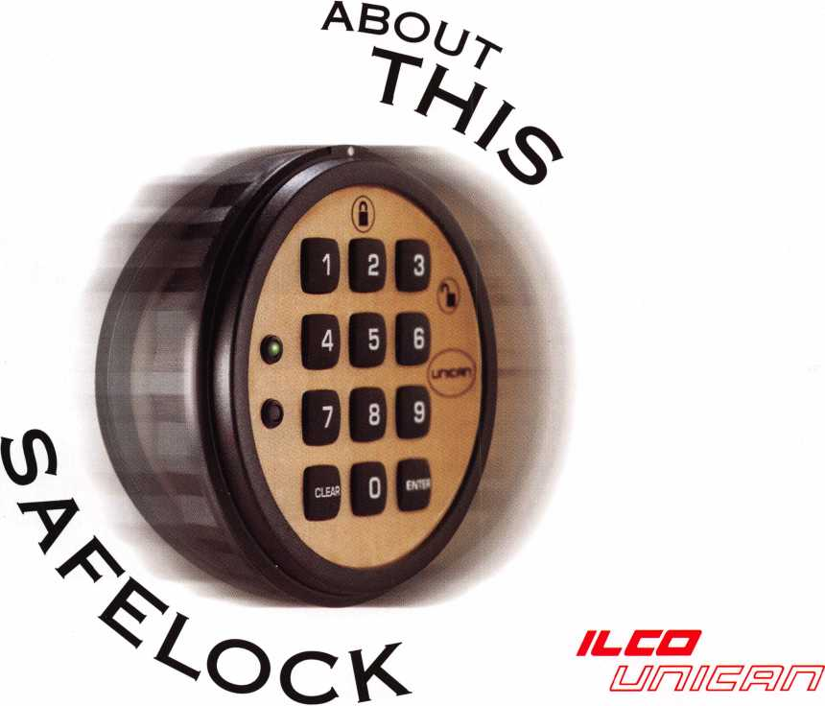

for more information, call 800-849-8324 or visit our website at [www.ilcounican.com](http://www.ilcounican.com)

it's patented inside and out. It might look like all  
the others, but the electro-mechanical SAFELOCK 515  
is exceptionally engineered. Its patented design  
includes Convert-A-Bolt™ technology for field-selectable

deadbolt / springbolt. It's packed with features. UL

listed Type 1, the SAFELOCK 515 features include four security levels and  
programmable dual custody, time delay, open window, tamper shutdown,  
and lockout. And it costs less. The SAFELOCK 515 is fully programmable  
from the keypad, requiring no distributor programming fees, expensive  
modules, or hand-held programmers. With more security for less investment,  
the SAFELOCK 515 is the ideal choice.

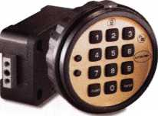

99

**Volume 45, Issue 5**

Contents

Features

May

The Cover:

When a customer dials your phone for help with a safe are you ready to vault into action? This month, we address the finer points of safe servicing.

Pictured is the Bank of Boston vault prior to its demolition over 20 years ago.

Art direction Valerie Rowe

Graphic design Lori Brennan

President’s Journey

By Dallas Brooks

Have You Considered a Home Safe?

Know your product and your customer’s needs. An insightful look at selling home safes.

By Claire Cohen, CML

16

Meet The Time Commander

Go through boot camp with our author as he delves into Sargent and Greenleafs new Time Commander!

By Brian Costley, CMS

20

Servicing Vault Locks

Helpful tips and a glossary of terminology to aid you in this procedure.

By Dan Graffeo, CMS

Safe Lock Cleaning and Lubrication

It’s a sticky job, but someone’s gotta do it. Get the technical facts from our expert.

By Don Dennis, CPL

27

Kwikset Residential Keyed Levers

Open the door to new and decorative hardware courtesy of Kwikset.

By Sal Dulcamara, CML

30

Mystery Safe

Our author plays detective trying to

open a mystery safe and finds some friendly help

from fellow locksmiths.

By Michael A. Ferill

33

Board Candidates

A peek at who’s running, where, and when. Voting information also provided.

40

Legislative Update

This month, Tim McMullen provides nationwide legislative updates.

By Tim McMullen

-i

Upcoming Events

8

Core

Brink’s goes mobile, plus tidbits from  
the security industry.

10

Security Marketplace

Applicants for Membership

Scheduled for clearance June 1

43

Authors in this Issue

Don’t forget to vote for Author of the Year

44

Backpage

Take Me Out To The Ballgame Contest

Keynotes

May 1999

34

Classifieds

36

Associate Members

39

Ad Index

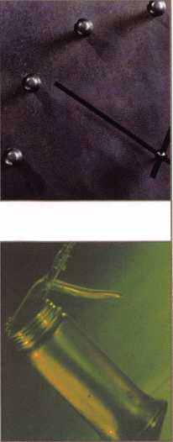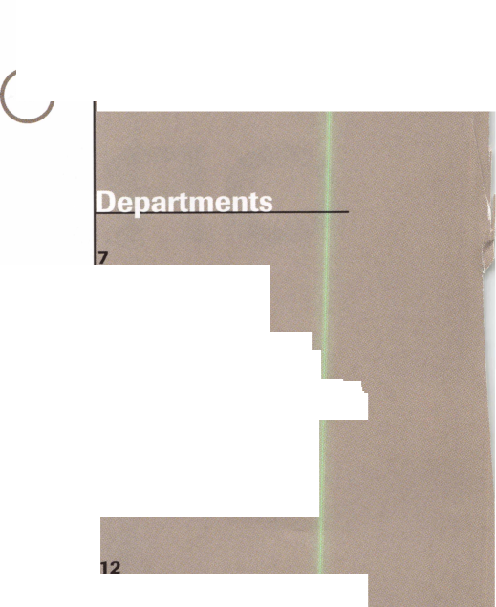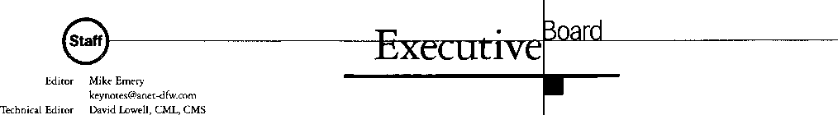

Communications Coordinator Editorial Advisor

Advertising Sales

Contributing Editors

Contributing Authors

ALOA Professional Staff Executive Director

Operations Manager

Receptionist Mail Room Coordinator Comptroller Finance Coordinator Meetings Manager

Meetings Coordinator Government Affairs Manager

PRP/Education Manager

PRP/Education Coordinator Membership Manager

Membership Coordinator

Chapters & Regional Associations Liaison

[david@aloa.ioffice.com](mailto:david@aloa.ioffice.com)

Patanya Johnson

John D. Cannon, CML

[jdcannon@worldnet.att.net](mailto:jdcannon@worldnet.att.net)

Marvin Diamond

Native American Journal Co.

(770) 998-7056

[thediamonds@mindspring.com](mailto:thediamonds@mindspring.com)

Paul Chandler, CRL

Claire Cohen, CML

Sal Dulcamara, CML

Jerome V. Andrews, CML

Brian Costley, CML, CMS

Bob De Weese, CPL

Ray D’Adamo, CML

James Glazier, CML

Daniel Graffeo, CRL, CMS

Wayne Gurnee, CRL

A.J. Hoffman, CML

Ken Holmlund, CRL

Ray Lusk, CML

Mark Ohno

Randy Simpson, CML

Robert Stafford, CPL

Dave Thielen, CML

Charles W. Gibson, Jr., CAE [charlie@aloa.ioffice.com](mailto:charlie@aloa.ioffice.com) Mary May

[mary@aloa.ioffice.com](mailto:mary@aloa.ioffice.com) Heather Reynolds Jeff Jordan Kathy J. Romo Janelle Vergara Jessica Smith [jessica@aloa.ioffice.com](mailto:jessica@aloa.ioffice.com) Janelle Vergara Tim McMullen [tim@aloa.ioffice.com](mailto:tim@aloa.ioffice.com) David Lowell, CML, CMS [david@aloa.ioffice.com](mailto:david@aloa.ioffice.com) Ashley Spencer Brandon Durrett brandon@aloa. ioffice .com Jackie Arnett [jackie@aloa.ioffice.com](mailto:jackie@aloa.ioffice.com)

Tim McMullen [tim@aloa.ioffice.com](mailto:tim@aloa.ioffice.com)

Medeco Security Locks

is a Grand Master Key Sponsor of the ALOA ’99 Convention and Security Expo.

Additional contact information for the ALOA Board and most Keynotes authors are available through “Locksmith Search”' on the ALOA website- [www.aloa.org](http://www.aloa.org) or by contacting the ALOA office at 3003 Live Oak Street; Dallas, TX 75204; 0800)532-2562,; FAX (214] 827-1810; e-mail [aloa@aloa.org](mailto:aloa@aloa.org).

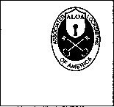

Mission Statement: The Associated Locksmiths of America, Inc. is dedicated to enhancing the professionalism, education and ethics among locksmiths and those in related sectors of the physical security industry. With approximately 10,000 members in the United States, Canada and the freeworld, ALOA is poised to help members obtain the knowledge, the strength, and the confidence to perform their role in the physical security field with pride and dignity. But it is only through active involvement and participation that ALOA can fully achieve its potential-and can help members to achieve theirs.

Policies: Keynoted is the official publication of the Associated Locksmiths of America, Inc. (ALOA). Keynoted acts as a moderator without approving, disapproving, or guaranteeing the validity or accuracy of any data, claim, or opinion appearing under a byline or obtained or quoted from an acknowledged source. The opinions expressed by the authors do not necessarily reflect the official views of ALOA. Also, appearance of advertisements and new products or service information does not constitute an endorsement of products or services featured by the Association. The Association does not accept responsibility for the inaccuracy of any data, claim, or opinion appearing in this publication, due to typographical errors on the part of the authors, Association staff or its agents. Editor’s Note: This publication is designed to provide accurate and authoritative information in regard to the subject matter covered. It is provided and disseminated with the understanding that the publisher is not engaged in rendering legal or other professional services. If legal advice and other expert assistance is required, the services of a competent professional should be sought.

Authors’ Payment: Payment for eligible submissions to Keynotes will be based on the following criteria: topic, time spent and past contributions. Authors who regularly submit to Keynotes are generally paid a higher rate. The latter is especially true of authors who write to fit specific editorial needs and submit said copy by Keynotes deadlines. As a general guideline: Average payment for a 750 word, business or ‘light’ technical article would be $200. Payment for a 1500 word article involving significantly higher time and research efforts would be $400.

Payment will not be offered for articles submitted by ALOA employees or members of the ALOA Board of Directors (unless material is of a technical nature), nor for articles submitted by a company that promote that company’s products or services. ALOA reserves the right not to pay for articles submitted by an individuals) that promote a particular company’s products or services.

Disclaimer: The Associated Locksmiths of America, Inc., (ALOA), reserves the right to refuse any article for any reason. Additionally, ALOA reserves the right to edit, amend or modify any article submitted for publication in order to preserve technical accuracy, clarity, fairness or grammatical correctness. ALOA will make the best efforts to notify the author of any changes. The extent of ALOA’s liability for any article or information contained therein will be a notice of correction or retraction in the next possible issue.

Keynoted* (ISSN 0277 0792) is published monthly except for the combined June/July issue by The Associated Locksmiths of America, Inc., 3003 Live Oak St., Dallas, TX 75204-6186. Telephone: (214) 827-1701; FAX (214) 827-1810; e-mail [aloa@aloa.org](mailto:aloa@aloa.org). Subscription rates for members-$15.00 per year. Second class postage paid at Dallas, Texas. POSTMASTER: Send address changes to: Keynotes, 3003 Live Oak St., Dallas, TX 75204-6186. © Copyright 1999, All rights reserved. No part of the contents may be reproduced or reprinted in any form without prior written permission of the publisher.

President

Dallas C. Brooks (334) 826-8990

Secretary

John D. Cannon, CML (703) 960-6413

Directors, Northeast

James H. Glazier, CML (301) 831-5454 John C. Magee, III

1. 845-3434 William L. Young, CML
2. ) 647-5042

Directors, Southeast

Jeffreys. Nunberg, CML, CMS (305) 324-8800 Donald E. Rul6, CML (601) 324-2658

Directors, North Central

Mark E. Blum, CML, CPS (517) 482-5809 John J. Greenan (773) 486-2030

Director, South Central

Randy L. Simpson, CML (713) 780-7026

Directors, Southwest

Gordon Racine, CML (719) 384-4707 John I. Shandy, CML (303) 774-9791

Director, Northwest

Scott Henke, CRL, CPS (907) 248-3785

Director, Associate Members

Judd Penske (800) 634-5465

Non-voting Directors

Jerome V. Andrews, CML (216) 642-3900 Steve G. Engel, CML, CPP (920) 731-5400

DavkH^Lowell.CM L, CMS (800) 532-2562 Breck H. Camp, CML (770) 455-6244 Henry H. Printz, CML (973) 538-2737 Leonard J. Passarello, CPL (416) 752-7210 Edwin Toepfer, RL (416) 225-5589

Chairmen of International Affairs

Laurence P. Mills/Australia (129) 958-0445 Hans Mejlshede, CML/Europe FAX (453) 139-1004

Past Presidents

1995-1997 David Lowell, CML, CMS 1993-1995 Breck Camp, CML 1991-1993 Henry Printz, CML 1989-1991 Evelyn Wersonick, CML, CPS 1987-1989 Leonard Passarello, CPL 1985-1987 Joe Jackman, CML 1983-1985 Stanley Haney, CPL 1981-1983 Louis LaGreco, CPL 1979-1981 John Kerr, RL 1977-1979 Clifford Cox, CML 1974-1977 Charles Hetherington 1972-1974 Gene Laughridge 1970-1972 William Dutcher, RL 1968-1970 Constant Maffrey, RL 1966-1968 Harold Edelstein, RL 1964-1966 William Meacham 1962-1964 Robert Rackliffe, CPL 1960-1962 Edwin Toepfer, RL 1956-1960 Ernest Johannesen

**May 1999**

Keynotes **li**

with Dallas Brooks

>»

CD

C

I

Time To Vote!

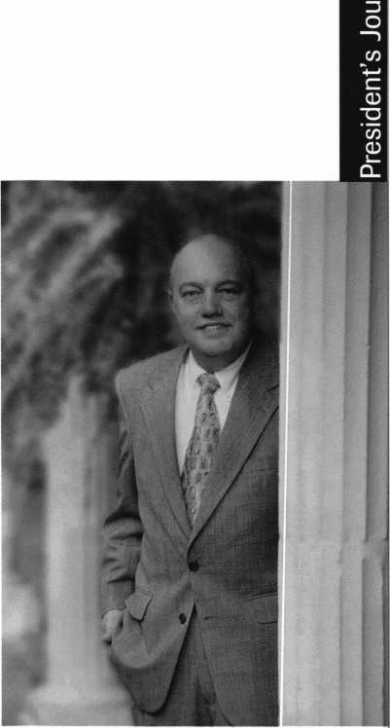

This issue of Keynotes contains a profile of candidates for election to your Board of Directors. It will soon be time for you to cast a vote for a new President of ALOA and in some regions, a new Director. The election ballots will be mailed out to you on May 29, 1999. Your ballots need to be returned via mail by July 8th.The election meeting at the ALOA office in Dallas, TX. The results of the election will be announced at the Annual Membership Meeting in Cincinnati, Ohio, during our Trade Show and Convention.

I wanted to use my article this month to urge your participation in our new Board election process. Your Board over the last couple of years listened to the desires of our members as expressed in the membership survey. We changed our bylaws to allow every member the opportunity to VOTE without requiring you to attend the annual membership meeting.

I supported the idea of vote by mail for many years and was very happy to see this goal achieved last year in Nashville. This is the first election by a mail-in proxy vote in which you will elect a new President for ALOA. You will also notice this is the first year we will have three candidates for this office and none were picked by a Board nominating committee. We do not have a nominating committee any longer, nor do we, as a Board, endorse any candidate. It was the Board's feelings that endorsing a candidate could have the appearance of hand picking your President, or a continuation of a “Good Old Boy” network. I assure you, if the Board ever was operating in this manner, it is history now. Your current Board is working very hard to do things right. All decisions by the Board are made after answering one question first; Will this benefit the majority of our members?

I truly believe changes made over the last two years are beginning to bear fruit. The new bylaws and our new governance policy are allowing ALOA to be run in a very professional business like manner. This was the main goal of my Presidency and I am very happy that we have achieved it. We could not have achieved this goal without the membership support shown at the membership meeting in Nashville last year. I thank all of you who attended.

Now, how many of you will pitch in and make our new system work? How many of you will exercise your right to VOTE? How many ballots will be mailed back in? I am counting on all of you to mark that ballot and drop it in the mail! Please do not let me down. I would love to be able to announce to the membership in Cincinnati that we received a 100% participation. I know this is not realistic, but I am hoping for a good response!

See you in Cincinnati!

Dallas C. Brooks President

May 1999

Keynotes

The Best.

Kwok-kei Leung Henry Raymond Toshihiro Asano Stewart Levine, CML Mary Ohmit, CPL Charles Robertson, CML Yuriko Yanai Jack Hobin, CPL Allen Konrath Salvatore Dulcamaro, CML Myeong-Rae Cho

|  |  |  |  |
| --- | --- | --- | --- |
| William Neff, CML | 35 | William Grant, CRL | 15 |
| David Lowell, CML | 32 | Walter Lascar, RL | 15 |
| Thomas Freehling, CML | 32 | William McElhenev, CML | 15 |
| Dana Barnum, CML | 31 | Gary Teams, CPL | 15 |
| John Heckman, CML | 30 | Thomas Vandersteen, CML | 15 |
| Jeanne Lodge, CML | 30 | Robert Duman, CML | 14 |
| Barry Leas, CRL | 28 | Russell Fuller, CRL | 14 |
| J. Thomas Hood, CML | 26 | James Gruber, CRL | 14 |
| John Elliott, CML | 24 | Daniel Landry | 14 |
| Danny Rudd, CPL | 24 | Rex Parmelee, RL | 14 |
| Lawrence F. Smith, Jr., CML | 24 | Keizo Taka has hi | 14 |
| Larrv Warnick, CML | 24 | Peter Gauthier, CPL | 13 |
| Roy Renderer, CML | 24 | Jon Griswold, CML | 13 |
| Robert Carroll, CPL | 23 | Frank Hartung, CML | 13 |
| James Watt, CML | 23 | Edwin W. Scott | 13 |
| Diana Barnum, CRL | 22 | Richard Sievers | 13 |
| Robert DeWeese, CPL | 22 | Paul Souber | 13 |
| David M. A. Federico | 22 | Steven Spiwak, CRL | 13 |
| Barbara Watt | 22 | Rolando Bouza | 12 |
| Jim Williams | 22 | James Brickler, CRL | 12 |
| Eugene Altobella | 21 | Joe Lee, CRL | 12 |
| Jerome Cohen, CML | 21 | Lonnie McKinney, CML | 12 |
| Anthony Ramunno, CML | 21 | Robert Rodocker, CRL | 12 |
| Charles Cole, CML | 19 | Donald Shiles | 12 |
| Elvis Hammerschmidt, CPL | 19 | Keiryu Tsukishiro | 12 |
| John Dorsey, CPL | 18 | Eric Veal | 12 |
| James Fowler, CML | 18 | Herbert Dusenberry, CML | 11 |
| David Harris, CML | 18 | John Enqel, CRL | 11 |
| D. Michael Lee, CPL | 18 | Robin Horsley | 11 |
| Marian Swann, CRL | 18 | William Lee | 11 |
| Ronald Heidzig | 17 | Raymond Lusk, CML | 11 |
| John Kerr, RL | 17 | Lester Brodsky | 10 |
| James Cawby, CML | 16 | Thomas Demont, CML | 10 |
| Joseph Ferrero, CML | 16 | Dale Knowles, CPL | 10 |
| Brian Reetz | 16 | Joseph Whitaker, CPL | 10 |
| Michael Robinson, CRL | 16 | William Wickward, CML | 10 |
| Philip Rovenolt, CPL | 16 | Ernest Wright | 10 |

How cart I join the Prtsfdent's Club?

You can earn membership in this prestigious club by  
recruiting just 10 new members for ALOA.

*Any ALOA member may participate.

What do 1 get?

When you recruit 10 members, you receive a handsome  
blue blazer with a President's Club crest. For each  
additional five members you recruit, you receive a  
lapel pin with gold-filled numbers, indicating your  
recruiting successes.

You also get the satisfaction of knowing that you are  
helping your association, helping your industry grow,  
and you are helping fellow locksmiths achieve success.

How do I get started?

Contact the ALOA office for a supply of applications  
(800) 532-ALOA or FAX (214) 827-1810. One President's  
Club credit is awarded for each new applicant. Credit is  
awarded only after the membership application is  
approved. However, the credit will apply for the period  
in which the application is received. Failure to identify  
yourself as the sponsor on the application form at the  
time it is submitted to ALOA for processing will forfeit  
any credit.

*AL0A Board of Directors not eligible for membership in the President's Club.

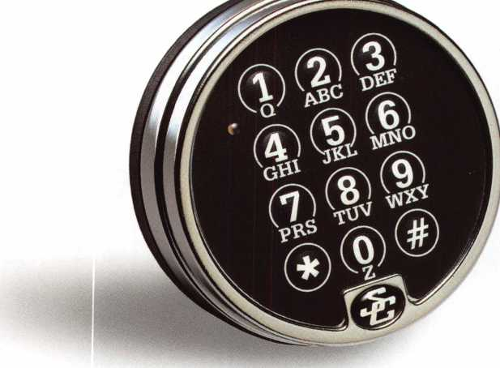

Simple Installation.

Quick Access.  
Maximum Security.

Choosing the right product, to meet your customers’ needs — as a security professional you’re faced with this nearly every day. And that’s exactly why you should specify Comptronic™ electronic safe locks from S&G.

**With the Comptronic...**

* there’s nothing to mark, measure or cut. With a standard footprint, just mount, plug in and your job is done!
* there’s nothing to spin, turn or retract. Simply punch in the access code and the Comptronic does the rest - automatically retracting the bolt for quick access.
* there’s no day-locking. After the bolt is retracted for six seconds, it automatically relocks, ensuring that the safe is secure against unwanted entry.

Call your authorized Sargent & Greenleaf distributor and order the Comptronic model that meets your needs. For specific product literature phone 1-800-826-7652, ext 315, or visit us at [www.sglocks.com](http://www.sglocks.com). Sargent & Greenleaf, Inc. — Security...Technology...Tradition.

COMPTRONIC

ELECTRONIC SAIE LOCKS

rail Sargent & Greenleaf, Inc.

See us at SAFETECH Booth #200

Upcoming

Events



Indicates ALOA ACE Class Indicates PRP Sitting

1999

MAY

3-8

SAFETECH '99 Las Vegas, NV

1. 827-7233

7-8

DHI Continuing Professional Development Seminar Toronto, Canada (703) 222-2010

8

ALOA PRP Sitting Las Vegas, NV SAVTA

Contact: David M. Lowell, CML, CMS (214) 827-7233 (214) 827-1810 fax

1. 16

Spring Meeting/Annual Trade Show

Wyoming Locksmiths Assoc. Contact: Fran McCumber 1026 Alger Ave.

Cody, WY 82414

14-16

OMLA Convention

Fifth SeasonTravel Lodge-

Oklahoma City, OK

Oklahoma Master Locksmith Assoc.

(800) 522-9458 (in OK)

(405)843-5558

(800) 682-0049 (out of state)

15

MBA Training Expert Lock Picking Nicholasville, KY (888)622-5495

16

MBA Training Expert Lock Picking Nicholasville, KY (888) 622-5495

JUNE

2-6

ELF Convention Hotel Haarlem Zuid Haarlem, Netherlands +31-23-537-69-07 (fix)

5

Investigative Locksmithing I Class Towson, MD Ramada Inn

Loch Raven Blvd. & Beltway 695 International Association of Investigative Locksmiths Rooms: (800) 272-6232 Don Shiles (reservation):

(800) 598-9491

Lenny Podgorski (reservation): (410) 516-8269

**\fcr\** Ace Classes Birmingham, AL Alabama Locksmiths Assoc. Contact: James Turner (334)793-5060 (334) 671-1405 fax

5-10

DHI Technical School Seminar Arizona State University Tempe, AZ

Contact: (703) 222-2010

6

1. th Annual Locksmith Swap Meet and Olympics Quality Inn Hotel Lyndhurst, NJ Contact: Jeff Sitar (973) 777-0620

11-12

DHI Continuing Professional Development Seminar Renaissance Cottonwoods Resort

Scottsdale, AZ (703) 222-2010

19

MBA Training Safe Deposit Locks Nicholasville, KY (888) 622-5495

20

MBA Training Time Locks Nicholasville, KY (888)622-5495

26

2nd Annual Swap Meet

1. Family Picnic Wisconsin Indianhead Chapter Valley Builders

Eau Claire, WI (715)832-4207

JULY

10-15

DHI Technical Schools Arizona State Univ Tempe, AZ Contact:

(703) 222-2010

22-25

DHI Chapter Leadership

Conference

The SunBurst Resort

Phoenix, AZ

Contact:

(703) 222-2010

25-31

ALOA ’99 Security Expo Cincinnati, OH (800) 532-2562

31

Locksmith Flea Market Milpitas, CA

The Silicon Valley Chapter of CLA 1444 S. Main Street Contact: Thomas Reeves-Messner (408) 262-5517 (408) 262-5517 fax [silvallock@aol.com](mailto:silvallock@aol.com)

AUGUST

i

ACE Classes Cincinnati, OH ALOA ’99 Security Expo (800) 532-2562

6-7

DHI Continuing Professional Development TBD

Seattle, WA (703) 222-2010

6-7

ACE Classes Albuquerque, NM New Mexico Locksmiths Assoc. Contact: Steve Highland (505) 268-8663 (505) 268-8802 fax

8

ALOA PRP Sitting Albuquerque, NM New Mexico Locksmiths Assoc. Contact: Steve Highland (505) 268-8663 (505) 268-8802 fkx

19-20

**^T\** ACE Classes Orlando, FL SERLAC

Contact: Austin Curry, CRL

(813)837-8488

(813) 839-1825 fax

22

ALOA PRP Sitting Baltimore, Md.

Clark Security Products Contact: Terri Burges (619)974-5273 (619) 974-5284 fax

22

ALOA PRP Sitting Orlando, FL SERLAC

Contact: Austin Curry, CRL (813) 837-8488 (813) 839-1825 fax

27-30

MLA’s London Convention Contact: Dave Stokes 139 Wood Street Walthamstow, London, E17 3 LX 01144 181 520 7450

SEPTEMBER

1. 19

GPLA Annual Convention

Philadelphia, PA

Jack Magee (registration)

(609)845-3434

Don Amole (booth space)

1. 288-5588 [www.gpla.org](http://www.gpla.org)
2. 19

TAOLs 26th Anniversary Convention International Plaza Hotel and Conference Centre Toronto, Ontario (888) 272-8265 (416) 321-5115 fax

1. 19

Distributors Show Inn of the Ozarks,

Eureka Springs, AR Ozark Professional Locksmith Assoc.

Betty Gray: (501) 524-3660 day (918) 427-1066 evenings or Bill or Janis Reves (501) 631-0017 day (501) 631-6406 evenings

OCTOBER

1—3

Jo-Van National Trade Show and Educational Seminar (416) 752-7249

10

ALOA PRP Sitting Burbank, CA Clark Security Products Contact: Terri Burges (619)974-5273 (619) 974-5284 fax

1. 18

DHI 24th Annual Convention and Exposition Dallas, TX Contact: DHI (703) 222-2010

17

ALOA PRP Sitting Coraopolis, PA Penn/Ohio Locksmith Assoc. Contact: Martha R. Eggler

1. 676-8464 (216) 267-2511 fax

29-31

Convention

Basildon, London

Master Locksmiths Association

London Region

Contact: D. Stokes

0181-520-7450

0181-521-8376 fax

[MLA_LR@hotmail.com](mailto:MLA_LR@hotmail.com)

NOVEMBER

6-10

1. Yankee Security Convention Sturbridge Host Hotel Sturbridge, MA

Rob Mahoney (800) 209-8266

1. APRIL

6-9

MLANJ2000 Annual Convention Somerset, NJ (973) 267-8884 (973) 538-2248 fax [www.mlanj.org](http://www.mlanj.org)

MAY

1-6

SAFETECH 2000 Birmingham, AL (214) 827-7233

JULY

23-30

ALOA 2000 Las Vegas, NV (214)827-1701

2001

MARCH

28-Apri! 1

MLANJ2001 Annual Convention Somerset, NJ (973) 267-8884 (973) 538-2248 fax [www.mlanj.org](http://www.mlanj.org)

JULY

15-22

ALOA 2001 Security Expo Baltimore, MD (800) 532-2562

2002

JULY

21-28

ALOA 2002 Security Expo Rosemont, IL (800) 532-2562

**May 1999**

Keynotes

L-

core

* ISC Miami to offer seminars in Spanish

Bi-lingual education hits the world of security expos at ISC Miami ’99 (May 4-5 at the Miami Beach Convention Center). For the first time, sessions will be presented in Spanish and Portuguese while various English classes will be translated into those languages.

* Security Lock and Ingersoll Rand

Security Lock has tightened its relation­ship with Ingersoll Rand by adding Schlage mechanical and electrical hardware to its distribution centers.

* Wind delivers

Wind Corporation recently announced that it was awarded the status of ‘Approved Source by the U.S. Postal Service for several Postal Locks and accessories. The locks are commonly used in U.S. Postal Service approved mailboxes around the United States.

* Paradox names reps

Paradox Security Systems recently announced that Bassett Sales Corporation will represent its products in Southern California, Southern Nevada, Arizona and Hawaii. They’ve also named Heitnereps, Inc. as an independent sales representative.

* Author of the Year

Just a reminder! Don’t forget to vote for Keynotes ‘Author of the Year.’ This month, we’ll have a special prize for some of the voters who send in their ballots! Look on page 42 for more details!

* Zip/area code changes

With all the recent changes being made to zip codes and area codes, your address or phone number may have changed in the past year. If this is the case, please let the Membership department know by calling (214) 827-1701. This way, we’ll be able to place the correct listing in the new ALOA Membership Directory.

* And they’re off!

Congratulations to James G. Campbell! James was the winner of our Horse Quiz contest. His correct answers were drawn from our numerous contestants (many of whom received an ALOA ’99 ‘Way Cool’ T- shirt!) James won passes and a limo ride to Cincinnati’s River Downs Track. Look on the Back Page (page 44) for this month’s contest.

* Execs

Ingersoll-Rand Company has announced the election of Herbert L Henkel as its president and chief operating officer.

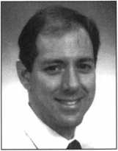

John Singleton Jeffery Hentschel

Security Lock has added two new faces to its Electronic Products Access Control Division, Jeffery Hentschel and John Singleton.

• Correction!

Last month, in the feature “Learning From the Ground Up,” Michael Rumage was incorrectly listed as Michael Rummage.

PRP

CML

John M. Shea, Staten Island, NY

CPL

Frank A. Cilente, Sayreville, NJ Rod Snell, New Cumberland, PA CRL

Carl Addison, Wilmington, DE

Jerry Bennett, Bettendorf, LA Paul Bentley, Portage, MI Spencer P. Caple, Ashburn, VA Mark V. Doyle, Mayfield Heights, OH Douglas Macqueen, Lakewood, OH Jack G. Oliver, Brown City, MI Michael **L.** Rumage, Erlanger, KY Joe Sprague, Marion, IL Ronald R. Shekels, Ankeny, IA Robert Wright, Jr.,

Hasbrouck Heights, NJ

• Regions

The Association of Ontario Locksmiths will be conducting exams for its TCPL (TAOL Certified Professional Locksmith) designation. Upcoming dates are June 6, September 19, and November 28.

For more information, call (416)321- 2219 or fax (416) 321-5115.

(Editor’s note: Would you like to see your regional association’s activities represented in Keynotes? Just fax all correspondence to 214-827-1810 or email to: keynotes@anet-dfw. com.)



• Obituaries

ALOA is sad to say goodbye to some  
of its most loyal members. The following  
locksmiths and security professionals will be  
sorely missed. Our prayers and condolences  
go out to their friends and families of Tom  
Vandersteen and Bryan A’Hearn.



May 1999

IL Keynotes

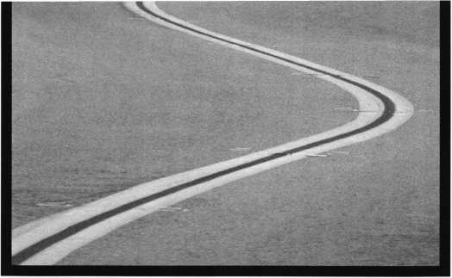

* On the road

After successfully providing home security for 16 years, Brinks is taking its show on the road. Actually, it’s starting its own mobile security division, which will provide its existing home security customers with safety and protection for their vehicles.

Brink’s Mobile Security was started as a result of an agreement with ATX Technologies. ATX, which has retrieved numerous stolen vehicles with its On-Guard Response Center is providing 24-hour directional and concierge services for Brink’s customers. To maximize its impact, Brink’s is using Global Positioning System (GPS) satellite technology and wireless communications as the tracking mechanism.

Among the other services ATX will provide as part of their service to Brink’s is safety and security monitoring, roadside assistance dispatch, theft recovery assistance and two-way voice communica­tion. It will also provide remote door unlocking and turn-by-turn directional assistance.

* Low voltage licensing news

There has been a new agreement reached between Georgia and Florida in the area of Low Voltage Licensing. The agreement allows an individual who holds a current Florida Low Voltage Contractor license who was licensed by passing the Florida Exam and meets the other Florida requirements to be issued a Georgia Low Voltage Contractor License upon submission of a properly completed application.

Conversely, an individual who holds a current Georgia Low Voltage Contractor license who was licensed by passing the Georgia Exam without the inclusion of veterans bonus points and meets the other Georgia requirements to be issued a Florida Low Voltage Contractor License upon submission of a properly completed application.

This recognition of licenses across state lines is extraordinary in the lack of additional requirements placed on the license holder. Both state boards are to be commended for taking this important step to reduce unnecessary redundant requirements across state lines.

* Fore!

The ALOA Open tees off Wednesday, July 28 during the ALOA show in Cincinnati. Sponsored by Yale, the event will feature breakfast, green fees, a golf shirt, hat and evening dinner event. Everyone who enters is eligible to win a variety of awesome prizes, including golf clubs, equipment and clothing. Plus, all participants receive a $100 banquet ticket. Interested players should reserve a spot with a $150 tax-deductible donation to the ALOA Scholarship Foundation. Space is limited, so send your name, address, phone number and ALOA Member Number (if applicable) right away to: ALOA Open ’99 3003 Live Oak Dallas, TX 75204

**EVERYTHING A  
LOCKSMITH NEEDS IS**

Stone & berg

At Stone & Berg, we stock a large variety of locksmith supplies and architectural hardware. With our 24 hour toll-free fax and no minimum order, you can place your order at any time of the day or night. Give us a call, we'll be glad to help, that's the 25 year tradition of ser­vice and quality you've come to know and trust.



**Stone & Berg**

Wholesale Locksmith Supply Company

(800) 225-7405 • Fax: (800) 535-5625

24hr.Toll-Free

May 1999

Keynotes

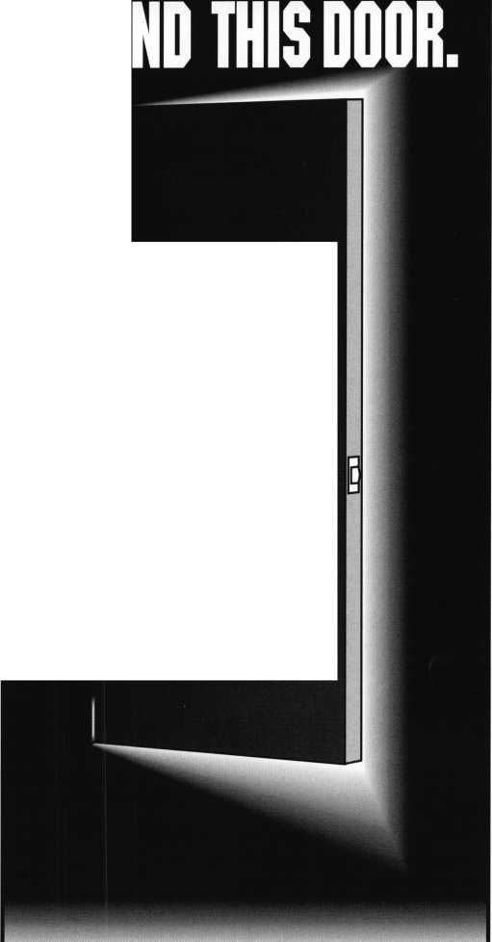

ADI

ADIs Spanish Language catalog is avail­able and features more than 100 pages of CCTV, Access Control, Fire, Burglary, Sound and Communications equipment for over 300 manufacturers. The catalog, written completely in Spanish, provides a variety of products with photographs, comparison tables, informative articles, glossaries as well as product offerings in access control and structured cabling. The entire catalog can be downloaded off the Internet. Just visit [www.adilink.com](http://www.adilink.com) and click on Espanol. To request a free copy of the Spanish language Catalog of Products call (800) 233-6261. ADI also announced another full line cata­log- Canadian style. It is 225 pages on security and low voltage systems. Complete with information on products from over 150 manufacturers, the catalog features a varied assortment of everything from multi-door access equipment, to Home Theater and even an extensive section on video badging. Plus ADIs newest section of the catalog features wire and cable for voice and data applications. To contact the nearest ADI Canadian branch call: (877) ADI-SERV.

ADI

Michael Drive Syosset, NY 11791 (516) 921-6700

Marks USA

Marks USA simplifies and hastens the installation of its Survivor Series key-in-lever locksets with the NEW J295 installation tool. TheJ295 thru-bolt installer is a rugged, self aligning tool with hardened drill bushings, drill bit and an adjustable edge guide; one edge guide; one edge for 2-3/4" backset, the other, for 2-3/8." Its designed for use with either wood or metal doors providing 5/16" thru-bolt holes on 2-3/4" centers. For application assistance or brochure contact:

Marks USA

5300 New Horizons Blvd.

Amityville, NY 11701

(516) 225-5400 or (516) 225-6136

Creative Commands Corporation

Creative Commands Corporation offers Handy Touch, the garage door opener transmitter/receiver-keep your garage stored

**10**1 **KeynotesMay 1999**

belongings safe and secure. Operating at 910 Mhz, Handy-Touch is the first micro-remote transmitter to use market tested code-rolling technology, making it virtually impossible for high-tech burglars to break your opener s code. The Handy-Touch garage door opener transmitter/receiver installs into your ciga­rette lighter socket, making for convenient access. Additionally, it draws power directly from the socket so theres no need to replace batteries. It is available for most American, Japanese and European cars. For more infor­mation on Handy Touch, contact:

Creative Commands Corporation 3121 Fujita Street Torrance, CA 90505 (310) 530-1965 (310) 530-9219fax

NAPCO Security Group

NAPCO introduces the Firewolf Advanced Photoelectric Smoke Detector- the first item in the line of commercial fire prod­ucts. It has been proven to provide detection of virtually all types of fires including paper, wood, gasoline, polystyrene and smoldering. The patented chamber and photo diode is designed for detection not formerly available in photoelectronics. NAPCO also introduced the Gemini Waterproof Personal Panic Button. The device is designed to be worn around the neck. A click of the button noti­fies the central monitoring station to dis­patch help immediately. The Waterproof Personal Panic Button is impervious to water so that it can be worn in the shower or outside in all kinds of weather. It features a single central oversized button for easiest operation, even with sight-impaired users. Another application for the panic button is as an under-the-counter/desk/table panic button in an office, retail establishment or a home. Special features of the GEM-WP PANIC include: Compatibility with all Gemini Wireless products, visual indicator which confirms transmissions or low battery, “quiet click” tactile response on button acti­vation, silver oxide watch battery which is easy to replace and waterproof, generously- sized plastic chain.

NAPCO Security Group (800) 645-9445

Vision Systems-ADPRO

Vision Systems manufacturer of ADPRO Video Transmission and Outdoor Video Motion Detection Products has introduced their new ADPRO Amux. ADPRO Amux is a highly advanced Video Display and Recording Multiplexer with 20 camera full- duplex color and black and white video. Amux affords quality solutions to many CCTV security and surveillance applications. The multi camera video output can be con­nected to industry standard composite,

SVHS or SVGA monitors. The multi camera displays are optimized by high-speed image processing technology.

Vision Systems-ADPRO 35 Pond Park Road Hingham, MA 02043

Samsung

Opto-Electronics America, Inc.

Samsung has introduced three real time digital black and white quad splitters for CCTV systems. There are three models available, SAQ-600, SAQ-601 and SAQ- 603. The three switchers incorporate real time performance-50/60 field per second; high resolution-256 level scale (8-bit); gen­lock auto switching function per camera input; compact design optimizing available workspace; screen menu programming: use software controlling many functions and ter­minals; quad picture border line and no spe­cial camera sync required. In addition, the SAQ-601 and SAQ-603 feature: four camera inputs with loop through; auto sequential switcher; individual camera full screen call­up; video freeze; alarm function; video loss detection; up to six character camera titling (alphanumeric); and time/date generator (on/off selectable).

Samsung Opto-Electronics America

40 Seaview Drive

Secaucus, NJ 07094

(201) 902-0347

(201) 902-1359fax

[www.simplyamazing.com](http://www.simplyamazing.com)

Master Lock

Master Lock Company introduced its Interchangeable Core System (Master Lock IC), offering facility managers full keying capabilities ready to use with their existing IC door security system. A Master Lock core

Security

Marketplace

fits any standard Best, Falcon and Arrow interchangeable core door lock. Master Lock’s full line of interchangeable core pad­locks, mortise and rim cylinders also accept present cores from these same brands. Master Lock padlocks can be ordered already keyed to match current IC Systems. There are 16 distinct keyway designs that match existing profiles from Best, Falcon, Arrow and others. Any authorized person using a single control key can remove an interchangeable core and replace it with a spare or recombined one, resulting in a new level of confidence and key control. Master Lock also offers door key compatible systems (for door locks that don’t use IC cylinders).

Master hock Company P. O. Box 100367 Milwaukee, Wl 53210 (800) 308-9242

Rockwood Manufacturing Company

Trim protection bars are available from Rockwood Manufacturing Company. Trim protection bars were designed to protect exit devices in hospitals, schools, retirement homes, office buildings, power plants, arenas and almost any public building from expen­sive damage. The bars, engineered with bends at specific angles, deflect traffic away from door trim. Two designs are featured: a modi­fied U-shape (Patent Pending), and a ramp- style design (Patent #5,867,941). The hinge end of an exit device may be protected by positioning a bar either directly below or over the hinge end of the device. Protection for door knobs and levers is achieved by mount­ing the product either directly below or in front of the lever or knob. Constructed of either 3/8" or 3/16" stainless bar stock, trim protection bars are through-bolt mounted. Other finishes are available on request. Rockwood Manufacturing Company (800) 458-2424

(800) 922-9212fax

Videx

Videx introduces their newest controlled access products, TouchAlert and TouchAccess. They are small access control devices that can easily be installed on file drawers, doorways, medicine cabinets, or anywhere you wish to track and control access. TouchAlert is a recording device with a local alarm and

TouchAccess adds an integrated lock to pre­vent unauthorized entry. Each authorized per­son is issued a small, durable Touch Memory “key” which has a unique ID number. Both TouchAlert and TouchAccess store a record of all entries, which can be read out later with a PalmPilot. In addition, the TouchAccess lock can be programmed to allow access to indi­vidual keys or groups at specific times of day. Videx

1105 NE Circle Boulevard Corvallis, OR 97330 (541) 758-0521 (541) 752-5285 fax tvtvw.videx.com

Panasonic

Panasonic Video Imaging Systems Company (PVISC), Closed Circuit Video Equipment has introduced several new addi­tions to the company’s extensive line of closed circuit video products. The new products include a Large Scale Matrix System, a Programmable System Controller, CCD cam­eras designed for covert applications, a line of Color Monitors and two new Power Zoom Lenses. Panasonic’s new Matrix System 850 is designed for large facilities. The system’s basic building block is a 256 camera input by 32 monitor output matrix card cage. When fully configured the Matrix System 850 can accommodate a maximum of 8,192 cameras, 1,024 monitors and 128 system controllers. The new WV-CU350 System Controller is designed for versatility and cost-efficiency in a variety of different system configurations. When used with the Matrix System 350 or WJ-FS616 Digital Duplex Multiplexers in series, the WV-CU350 provides full-function control capabilities for each system. When used with the Matrix System 850, the WV- CU350 is a cost efficient alternative for con­trol sites that require basic operation. Panasonic introduced cameras designed for covert applications. The new products include: the WV-CF420 color and WV- BF320 black and white CCD cameras designed to appear as common smoke detec­tors; and the WV-CF400 color and WV- BF300 black-and-white CCD cameras in the form of standard passive infrared sensor. A new line of color monitors specifically designed for CCTV applications has also made its debut from Panasonic, the 14-inch WV-CM1430, the 14-inch WV-CK1420 and

the 20-inch WV-CK2020 . All three units feature audio inputs/outputs. In addition, Panasonic is demonstrating the new long range WV-LZ61/15 15X Power Zoom Lens and the general purpose LZ61/10 10X Power Zoom Lens.

Panasonic One Panasonic Way Secaucus, NJ 07094 (888) PAN-CCTV

Zero International Inc.

The 1999 catalog for Zero International’s complete line of door and window gasketing, thresholds, saddles and high-performance continuos hinges celebrates 75 years of design and manufacturing innovation. The 36-page catalog provides specification guidance and full-size schematics for hundreds of compo­nents and integrated systems for blocking flames, smoke, air, light and sound. It high­lights recent innovations in Zero’s intumes- cent technology and systems that can help both manufactures and specifiers comply with the positive pressure requirements of ICBO’s UBC 7-2 1997 Fire Door Standard. The new catalog also highlights Zero’s UNIGEAR continuos hinge systems. For more informa­tion or a catalog, contact:

Zero International

415 Concord Avenue

Bronx, NY 10455-4898

(800) 635-5335 or (718) 292-2243

(800) 851-0000 or (718) 292-2243 fax

[Zero@zerointemational.com](mailto:Zero@zerointemational.com)

Security Lock Distributors

The complete line of Simplex mechanical push-button access control products is described in a new 64 page Simplex Products Catalog offered by Security Lock Distributors. Included is specific information on all heavy duty primary locksets, exit device and switch controls, narrow stile door locks, primary locksets, auxiliary and cabinet locks as well as all accessories and options. The catalog contains detailed exploded views showing positioning of all components, pho­tos of same, plus basic installation informa­tion, dimensions, electrical ratings, finishes, functions and styles. The catalog is free. Security Lock Distributors (800) 847-5625 (800) 878-6400fax [www.seclock.com](http://www.seclock.com)

**May 1999**

Keynotes **in**

Applicants

For Membership

Dept

***y The following applicants are scheduled for clearance as members of ALOA. The names are published for member review and comment prior to June I, 1999, to ensure applicants meet standards ofALOA’s Code of Ethics. Protests, if any, should be addressed to the Membership Department and must be signed. Active Membership applicants (A) have worked in the indus­try two or more years. Allied Membership (AL) applicants are not locksmiths, but work in a security-related field. Apprentice Membership (AP) applicants have worked in the industry less than two years.***

USA

ALABAMA

Montgomery

Jeffrey S. Marks, A Anthony R. Staten, A SPONSOR: Dallas Brooks

ARIZONA Fort Huachuca

Mark R Stephens, AP

Phoenix

Tim Restad, A SPONSOR: William Lee

CALIFORNIA

Anaheim

Barry A. Burdette, A SPONSOR: Daniel Enriquez

El Centro

Carol L. Reiter, AL

Modesto

David E .Pavao, A

Pomona

Art M. Norton, AP

COLOFADO

Cortez

Kris Cashner, AP

Denver

Perry Hashman, A Gregory D. Henry, A SPONSOR: Ronald Kay

CONNECTICUT

Ledyard

Brian J. Hill, AP SPONSOR: J. Vessels

FLORIDA North Miami

Ron Roby, AP SPONSOR: Roy Renderer

Ocala

Irving Isicoff, A

ILLINOIS

Decatur

Larry D. Sweeney, AP

Oak Park

Xavier Delao, AP

Rock Falls

Fred L. Johnson, A SPONSOR: Russell Zehnacker

KENTUCKY

Winchester

Justin G. Stead, A SPONSOR: Jon Vawdrey

MASSACHUSETTS

Boston

Peter Kasarda, AP SPONSOR: Glenn Hove

MICHIGAN

Lansing

Michael Sparks, AP

Monroe

Ric Moran, A SPONSOR: Pedro Portillo

MINNESOTA

Brainerd

Gina L. Teems, A SPONSOR: Gary Krause

Buffalo

John E. Harnois, AP SPONSOR: Russell Point

Minneapolis

James M. McDonald, AP SPONSOR: John Heckman

Minnetoka

Ben D. Regenold, AP SPONSOR: Charles Regenold

MISSOURI

Linneus

Scott M. Graham, A

MONTANA

Hamilton

Matthew R. Swafford, AP SPONSOR: Martin Peirce

NEW JERSEY Belle Mead

Stan A. Weinstein, A SPONSOR: Bruce DeRoma

Cinnaminson

Robert M. Neville, A SPONSOR: Clifford Shafer

Hamilton Square

Michael S. Dohrenwend, A

NEW MEXICO Albuquerque

David Richard, AP SPONSOR: Christine Baca

NEVADA Las Vegas

Jackie Z. Baker, A SPONSOR: Joan Woodell

OHIO

Youngstown

Gary J. Mottram, A

OKLAHOMA

Ardmore

James T. Castleberry, A SPONSOR: Donald Rule

PENNSYLVANIA

Johnstown

Marque H. Doucette, AP

Philadelphia

George L. Griffin, AP

TENNESSEE

Madison

Jerry L. Gabbard, A

TEXAS

Dallas

Chad A. Doerr, AP

Forney

Warren W. Stephens, AP

Houston

Michael F. Wishnow, A SPONSOR: Ronald Schultz

Lumberton

Harry B. Roberts, A

VIRGINIA

Arlington

Jeffrey A. Emily, AP SPONSOR: Michael Groves Glen H. Schoenberg, AP SPONSOR: Michael Groves

New Church

Thomas L. Bowden, A

Springfield

James L. Bickers, A SPONSOR: Donald Shiles Patrick W. McMasters, A SPONSOR: William Dalton

WASHINGTON

Belfair

Bob A. Case, A SPONSOR: Paul King

WISCONSIN

Beloit

Eric M. Kuikman, AP SPONSOR: Alan McCauley

BELGIUM

Koksyde

Marc Blonde, A SPONSOR: Paul Viaene

JAPAN

Chiba City

Yuichi Nagano, A SPONSOR: Keizo Takahashi

Chiyodaku /Tokyo

Koto Mitsukuni, A SPONSOR: Kazuhiro Aikawa

Kwasaki, Kanagawa

Tsutomu Komatsu, A

NETHERLANDS

Almere

Joel G. Lowenberg, A

SINGAPORE

John Woon, A

THAILAND

Bangkholaem, Bangkok

Thanyaluk Pitisettakarn, A

A & B SAFE

CORPORATION

#1 choice of safe specialists  
& security consultants

A & B is a leading manufacturer of quality  
depository safes & chests.

UL rated composite safes  
TL-15 TL-15/6 TL-30 TL-30/6.

Custom safes manufactured to your  
specifications.

* fire safes • vaults class I, n, ID
* insulated files • chests
* truck safes • wall safes
* gun safes • media/data safes

OVER 75 MODELS IN STOCK  
SHIPPING YOUR ORDER  
WITHIN 24 HOURS

For fast accurate quotes call

1-888-723-8054 • 1-609-863-1186  
or fax to: 1-609-863-1208

171 South Delsea Drive  
Glassboro, NJ 08028-6237

12| Keynotes

May 1999



wm$m

**Have** {jfeOD

By Claivc L. Cohe*, C/V1L

Considered

A Home Sale?

Statistics show that a large percentage of people in the U.S. will experience at least one structure fire and/or burglary in their lifetime. No home or business is completely insulated from fire or theft. During these incidents, vital records and possessions are lost. Perhaps some of these losses could be prevented if documents or valuables were stored in fire or burglar-resistant safes.

ARE You overlook An opportunity?

As a locksmith, you are probably called upon to provide informa­tion on residential security or perform security surveys. This may be an opportunity for you, the professional locksmith, to sell home safes as an add-on sale to deadbolts, doorknobs and other security devices. In addition to securing exterior doors with deadbolts or other devices, a home safe can provide added security, safety and peace of mind.

**t>0 You WAVt** THE KNOWLEDGE?

The first step in selling a safe is to be prepared with knowledge  
about the different types of safes available (fire, burglar and specialty).  
Different manufacturers design and build safes to meet or exceed  
many different needs. Be educated in the different types and brands  
of safes. Be conversant with the sizes and styles as well as the  
relative merits of different types of safes such as floor, wall, in

the floor, etc. Your customer will expect you to know  
delivery time as well as manufacturer guarantees and  
warranty information.

Know the various features of safes. Some safes  
have options such as a locking drawer, storage

tray, adjustable shelves and/or dividers (horizontal / vertical). Some safes are available with different methods of opening - an electronic lock, key lock, combo lock, dual locking, etc. Some safes come in different colors, which could be a selling point. Know the exact price of any safe you sell, including shipping and delivery costs.

Safes are rated according to insurance company classifications. Generally, the higher the classification, the more insurance companies will insure the contents for. Also, know some of the more common Underwriter’s Laboratories (UL) Standards.

EIRE PROTECTION

UL Label/Class 350 degrees - 1 hour: The safe will maintain an interior temperature less than 350 F when exposed to fire for a period of one hour at 1700 F. Safes must successfully undergo all other requirements for the Fire Endurance Test, Explosion Hazard Test and the Fire/Impact Test. PRIVATE “TYPE=PICT;ALT=Classified UL: Fire Resistive Safe Class 350.

Burglary protection

Safes with the Class “B” or Class “C” Burglary Insurance rating  
allow the safe owner to receive insurance coverage in accordance

with the Broad Form and Mercantile Safe Insurance classifica-

tions. Pertinent insurance information is available from  
Insurance Service Office, 160 Water Street, New York,  
New York 10038.

5

May 1999

Keynotes



**Don't** overlook **DAtA/mEDiA sAEEs.**

Today, many people are interested in storing Computer Media (tapes, discs, etc.) in a safe. Most modern safes provide protection from fire by holding moisture in the insulating material until the temperature on the walls or the container becomes hot enough to turn the moisture into steam. This prevents the contents from charring.

Computer data/media requires special considerations **-125** degree protection with less than 80% humidity. UL ratings on data safes require a drop test simulation also. Data ratings can also be obtained by storing a “Data Container” inside a UL rated one-hour container. A data container is tested to ensure that in one hour 350 degree temperature (inside another UL 1-Hour Fire Rated safe) the contents do not exceed 125 degrees and stay below 80 percent humidity.

3UN SAFES

There are a wide variety of gun safes on the market. From basic models to ultra luxurious velvet-lined interiors, sizes and styles vary widely. Some models may be equipped with interior fittings to customize to your buyer s needs.

THE SALES PRESENTATION: BE ARMED WITH THE

**MA*£ /OUR customer AwARE.**

Your first contact with a customer may be on a service call for a minor lock repair or for a small purchase. As with all sales calls, first impressions are very important. Your intent should be to elevate yourself as an expert in home security and to acknowledge concerns about total home security. No door should be left vulnerable and in the same context, other areas of home security should not be overlooked. If your customer displays interest, pursue discussion on home safes. Years ago, there was a limited number of choices for home safes. Today, the consumer has many choices of styles, brands and qualities. The professional locksmith separates the customer s individual needs from the volume of choices.

Listen to what your customer is saying and to obtain feedback and help the customer make the proper decision for his/her individual needs and desires.

Through conversation, you may be able determine:

* What type items do they need to store?
* Birth certificates, wills, important papers documents, mementos and keepsakes.
* How much area do they need?

® How much area do they have for storage?

* Will this be for photos, computer media, and video tapes?
* Will they store jewelry?
* Will they store guns?

® Does your customer’s insurance company require a rating on the safe?

* What is their expectation of product performance?
* What quality do they want?
* Would they need organizational features (i.e. drawers, shelves)?
* How are they are storing valuables now, and what they like and/or dislike about the method?
* Is your customer confident that his valuables would survive with their present storage system?

Selling a safe can sometimes be a difficult task. It is up to you, the professional locksmith, to make your customer aware of the benefits of owning a safe. SELL BENEFITS! Make the consumer aware that a safe, adequate to their needs, can provide additional security, safety and peace of mind.

You should have complete literature available for each make and model you describe. (Occasionally, you will need to research informa­tion on a particular type of safe or model and may need to make a follow-up presentation.) As a suggestion, for a more professional presentation, have all safe literature in one consolidated book, divided by brand and style. Retail price lists, with options, should be a part of this book. Have handouts available for your customer to review.

Plan your sales presentation and be prepared to answer questions and concerns. Offer a triplicate of choice. Work from the top quality down. Show the first, then middle quality and then a lower quality.

Be an expert on the product. Know the product availability. Be brief and repeat key parts if necessary, summarizing at the end.

One subject that may come up is used safes or old safes. If this question arises, explain that they should not consider any old safes for fire protection. Older safes were made with a concrete material as the heat retardant material. This type of concrete material has a tendency to crack and crumble. The consumer will never know of the concrete condition inside the iron casing on an old safe. Although many of these old safes are very beautiful they have more of a nostalgic value than a fire protection value.

If your customer decides not to buy, thank him anyway for allowing you to present the materials. You have planted the seed, and some will decide at a later date to purchase a safe from you. You have to play to win. If you never mention safes, your customer will not know that you offer them for sale. Thank your customer for the opportunity of talking to them about a safe. After your sales presenta­tion, analyze what you could have done better or what you should have done to close the sale, and improve your selling techniques.

Valuables are only as safe as the quality of protection we provide for them. Are your customers confident that their valuables will survive with their present storage system? Sell benefits of ownership! Sell safes!

"Make tke donsuimer a*/are tkat  
a safe, adequate -to tkeiv- needs,  
dan provide additional security,  
safety and fcade of mind”

VISA

C. ATM

DEBIT

CARD



Diners Club ***International‘***

Accept Credit Cards  
and Increase Sales and Profits  
by 30% - 50%

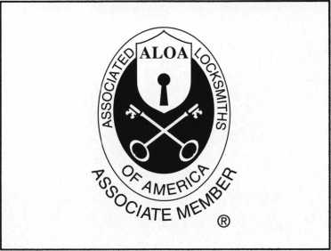

There are three reasons why people don’t accept credit cards:

Through Association Benefits **^** 1. Too expensive.

These Concerns Are Eliminated 2. The paperwork hassle.

3. Inability to qualify.

Here’s how it works:

* Simply swipe or enter the credit card #.
* Enter amount of sale.
* Approval within seconds.

No Hassle - Easy Qualifying

Funds wired electronically into your local checking account within 48 hours.

.'E-.;: ;;.,V

New Account Set-up Options (Check)

Package A □

Package B □

Deluxe Package C 1—1

Free Pin Pad Program For Currently Processing Merchants n

Because of your association membership, nearly 100% of all retail and home based applicants

will be approved even with past credit problems.

Currently Processing Merchants Please Read

Monthly Lease To Own Set-Up Options

Special Low Discount Rate and Transaction Fee: 1.59% + 20$

Plus Monthly Statement/Customer Service Fee: $10

Package A: $29.95 Terminal

Package B: $39.95 Terminal & Printer In One

Deluxe Package C: $49.95 Portable Terminal/Printer/Pin Pad  
Debit acess fee Ability to Accept Visa/MC “Check Cards”

Sio/mo. & ATM Cards ataFLAT 25*

Totally Himinating the 1.59 % Rate  
(All lease terms 48 months • Monthly minimum $25)

] I authorize Universal’s sales office to print and deposit a check  
in the amount of $49 (normally $125) for my application fee which  
covers initial materials, application processing, equipment warranty,

shipping & handling, programming, installation and training.

* Fill out a check, tape here above mini form and then fax.

Fax Express Mini Form Now To 1 -800-439-7773

Company Name.

Contact Name

Address

City

State-

Phone

Best Time

Signature

A subsidiary of Universal Savings Bank, FA.

Marketing Office ***1****-****800****-****836-4295***

Universal Payment Processing Provides 24 Hour Live Customer Service.

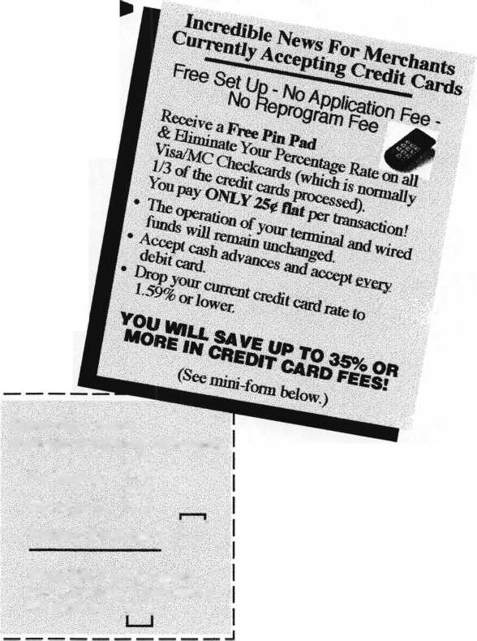

Meet the Time Commander

“Paradigm shift” is a phrase that has hate—electronic safe locks. It just doesn’t ••Time delay override (dual control)

escaped from sociology textbooks and Vseem fair to spend two decades of one’s life •• Audit trail

become a common part of our everyday mastering mechanical safe locks only to find ••Remote enable/disable

language. It refers to a change in perspective another steep learning curve staring us in the ••Multifunction time lock

brought about by a fundamental change in face. That’s especially true when the ••Surveillance camera activation

one’s beliefs or environment. For instance, introduction of new technology levels the Chances are your customer would react in

there was a time when it was commonly playing field for both old and new one of two ways. He would either try to think

believed that the earth was flat. When the technicians. It’s as easy for a newcomer to of a way to use as many of the features as

combined forces of science and global become proficient with the new locks as it is possible (whether he would actually benefit

exploration made it obvious that the earth is for the experienced, venerable master. Foul! from them or not), or he would succumb to a

round, a paradigm shift occurred in people’s The good news is that electronic safe locks growing sense of confusion and explain to

thinking. Their model of the earth’s shape are becoming easier and easier to work with you how he really loves his old mechanical

changed radically. Some people embraced as the technology matures. The better news lock and all of its known idiosyncrasies,

the change while others simply refused to is that even the simplest electronic locks The better approach is to get your

accept the new model. provide more versatility than their mechanical customer to share his security concerns with

Although less universal in scope, we have ancestors. You can satisfy more of your you. This is the time to simply listen to his

the same cultural change occurring in the customers’ security needs (at increased problems and fears. He expects you, as

safe industry with the proliferation of profits) by offering solutions instead of someone he has confidence in, to devise a

electronic locks. When I began working with pieces of hardware. solution. With all of the options available in

safes, the mechanical lock represented the The traditional method of selling involves today’s electronic safe locks, much is

state of the art. The technology had been with taking the product to the customer and possible. Sometimes you can accomplish the

us for over one hundred years. It was well extolling all of its features and benefits. This entire solution yourself, and sometimes you

developed by the manufacturers and well method doesn’t lend itself to electronic safe need to work with other professionals, such

understood by those of us who maintained it lock selling. The features are often numerous as when you use a lock’s bolt position

in the field. This period is what those of us in and somewhat confusing. How many indicator to shunt the alarm provider’s safe

mid life (or beyond) commonly refer to as customers do you have who really would door circuit. Most alarm companies are

“the good old days.” That doesn’t actually benefit from all of these features in a single happy to work with you, providing you

mean the times were good, but simply package? approach the project in a professional,

reflects our fondness for the time period as ••Single user mode with multiple users cooperative manner. They may even

we selectively recollect it. That level of comfort can be a wonderful, stress-reducing facet of our lives. Unfortunately, it doesn’t foster true progress; and progress is the fuel that modern business feeds on voraciously.

All this is leading up the subject we love to

••Dual user mode with multiple users ••Supervisor/subordinate mode with multiple users ••Variable time delay ••Variable time delay opening window ••Time delay override (single control)

recommend your security solution to their other customers when they see how well it solves a particular problem. You do like new business, don’t you?

All this is academic, however, unless you  
develop a sense of what can be done with the

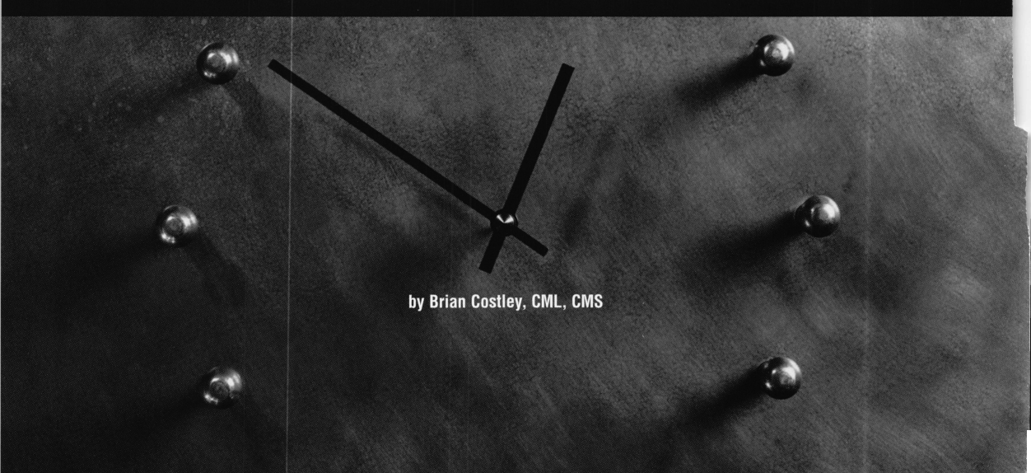

new electronic locks and their myriad  
accessories. It’s also necessary to develop a  
sense of confidence in your ability to install  
and program these new marvels. To help  
alleviate the dread of tackling new  
technology, we’ll take a step-by-step look at  
adding a multi-function time lock to a  
Sargent & Greenleaf Comptronic® lock.  
Although the actual installation instructions  
are a bit more detailed, this overview will give  
you a real feel for the hands-on work.

I remember an article that my friend Dan  
Graffeo wrote for one of the first issues of  
Safe & Vault Technology many years ago. It  
showed the work necessary to add a two-  
movement time lock to a safe door. It  
involved things like fabricating a mounting  
plate and welding it to the safe door, as well  
as making and installing a snubber bar. The  
time and required planning were consid-  
erable, but the end result was a truly  
worthwhile upgrade to an existing mechanical  
locking system.

With today’s electronic locks, the same  
upgrade can be accomplished in a fraction  
of the time, at less cost, and offer many  
more features. And most of those features  
are much easier for the customer to use.

In addition, the smaller size of the new  
components allows the time lock upgrade  
to be applied to a much wider range of safe  
doors. Available mounting space is much  
less critical.

The lock in our upgrade is an S&G 6123,  
mounted in a small, “C-rate” door. There is  
very little room to mount anything extra in  
this door—virtually no extra room under the  
back plate. The electronic lock is a Time  
Commander II®, which offers a repeating  
weekly program that can accommodate  
several openings and closings per day,  
vacation time periods, automatic daylight  
savings time changeover, and unscheduled  
closing periods. It’s also fully Y2K compliant.  
If you want a copy of the complete feature  
list and operating instructions, it’s available  
on S&G’s fax-on-demand system. Call  
(606) 885-9411 from the handset on your fax  
machine. When connected, dial extension  
550, and follow the voice instructions. The  
document number for Time Commander  
Instructions is #580. All documents are in  
“fine” mode. They take longer to download to  
your fax machine, but the quality is higher  
than normal.

Experience teaches us that first instal-  
lations always take the longest. They are  
valuable learning experiences, and are paid  
for in our time. With one or two Time  
Commander installations under your belt, the  
time required should be around twenty  
minutes. If you add in prep time,  
programming, and cleanup, one hour should  
be adequate. With that in mind, let’s proceed  
with the installation.

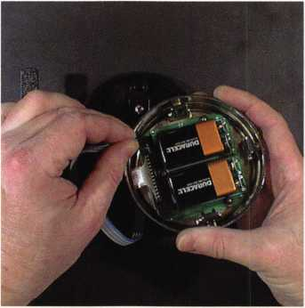

••If the electronic lock is already installed on the safe, it will be necessary to remove the keypad. Disconnect the ribbon cable that comes through the safe door and plugs into a receptacle in the back of the pad. Always unplug the cable by pulling on the connector, never on the cable. Put the keypad aside for now.

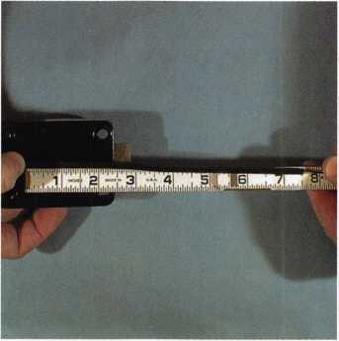

••In the Time Commander kit is a special cable that will be used to connect the electronic lock’s keypad to a junction box to be mounted inside the safe. This cable will be routed under the lock case so that it can run through the safe door spindle hole and connect to the keypad. To make sure there’s enough cable to allow for installation and removal of the keypad, leave about eight inches (20 centimeters) of extra cable.

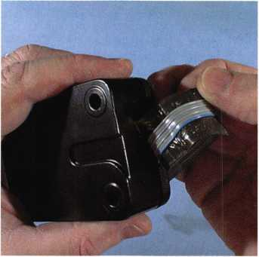

••Take out the mounting screws and remove the lock from the safe. As you do so, take care to prevent the ribbon cable (permanently attached to the lock) from scraping against rough metal surfaces. This cable is the lock’s lifeline. If it is damaged, you can count on serious operational problems that occur immediately or at some point in the future.

•• It is not necessary to remove the lock cover. Doing so will void the manufacturer’s warranty, and the little men that operate the motor will escape.

••The next step is to fix the cable into the recessed channel in the underside of the lock case using the self-stick foam pad removed from the original cable. The Time Commander cable is simply taking the place of the original lock cable. The new cable must be within the recessed channel of the lock.

If it is out of position at any point, it will be partially crushed when the lock is fastened in place, leading to eventual problems.

••Carefully pull the ribbon cable and the self-stick foam pad that covers it away from the lock case. Then peel the foam pad away from the cable. The pad will be re-used to hold a different cable against the lock case.

May 1999

***Keynotes^***

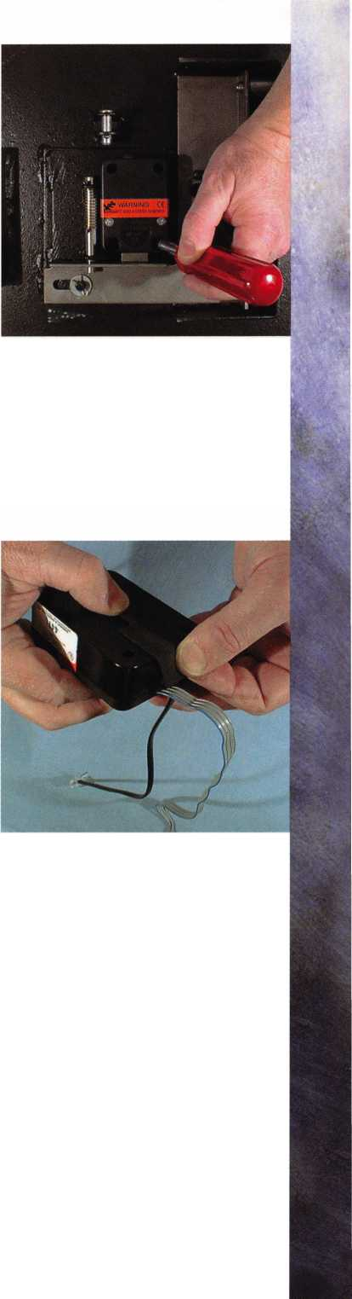

••Use standard electrical tape to wrap both cables together where they will come through the safe door’s back plate. Use several layers of tape to protect the cables against sharp or rough metal surfaces.

-Yes, it looks like a confusion of cables, but the connections are extremely simple (of the “A plugs into A” and “the keypad plugs into the receptacle with the picture of the keypad next to it” variety). Excess cable is coiled and held out of the way with wire ties and self-adhesive tie blocks. Again, it’s important to make sure components and wires won’t be disturbed when the door is opened and closed.

-The Time Commander comes with complete programming instructions to allow multiple openings and closings for each day of the week and a number of other features. The program repeats weekly unless new commands are entered.

-Install the back plate. Most of these plates already have a hole in them to allow insertion of a change key for mechanical locks. If this hole is absent or in an inconvenient location, a new hole (minimum diameter of 5/8") will have to be punched or drilled. If this is done, it’s important to remove any burrs or sharp edges.

-Plug the Time Commander cable that runs through the safe door spindle hole into the receptacle in the back of the keypad. Press the keypad back on its mounting base, being careful not to crush the cable.

-From outside, the safe looks the same as it did before the Time Commander was installed...with one exception. It is critically important to add a prominent notice that the safe is now protected by a time lock. In case of armed robbery, it must be made obvious that store personnel do not have control over the unlocking of the safe.

-Run the Time Commander cable through the safe door spindle hole, and fasten the lock in place, using the original mounting screws. Note that all of the original lock cable is inside the safe door. One end of the Time Commander cable is also on the inside of the door.

-The Time Commander and junction box can be mounted anywhere inside the safe. The only limitation is the length of the connecting cables. It usually makes sense to mount these components on the back plate. Wherever they are mounted, it is important to make sure that the components will not be contacted by other parts of the safe or its contents when the door is closed. The Time Commander and junction box could be damaged, or programming buttons could be inadvertently depressed under such conditions. If such an occurrence is likely in a particular installation, it might be wise to cover the Time Commander with a thermostat cover or similar protective enclosure.

eynotes

May 1999

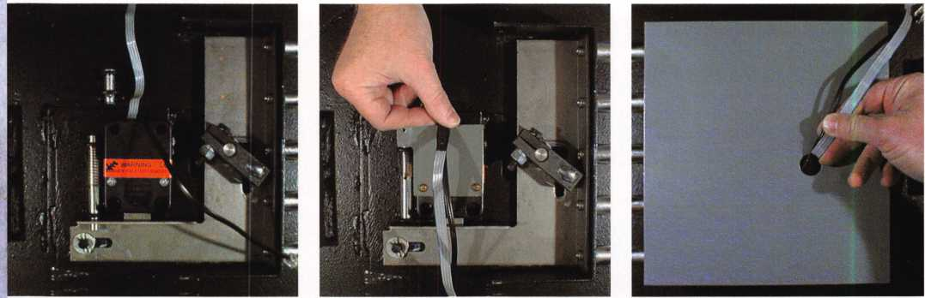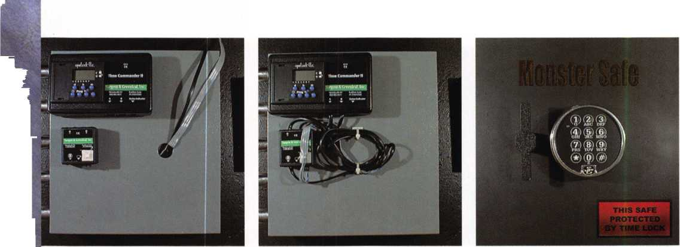

We've Unlocked the Secret to Selling Safes!

**Introducing Meilink's New Sales Promotion Program.**

Secure more sales and increase profits with Meilink’s sales promotion program, the

safe industry’s first comprehensive dealer marketing package. It starts with a Meilink exclusive. A fire and burglary rating system that

**For more information contact Grant Hart at:**

**1-800-MEILINK**

**111 Security Parkway**

**New Albany, IN 47150**

simplifies comparison shopping for consumers. Meilink follows through with promotional materials, attractive displays, and other persuasive marketing tools that practically push Meilink safes into your customer’s hands Put Meilink’s marketing power to work and watch our complete line of composite, plate, and cash-handling safes leap to the top of your best-seller list.

MEILIISK



vault Locks

by Dan Graffeo

S

enticing techniques utilized to maintain vault locks vary widely. Dependent upon which company, demographic location and vintage in which you were trained, your technique can either be considered comprehensive or exiguous. One of the basic rules I follow when I discuss service with a technician is to listen to their explanation of service without comment. From a cursory position, the first comments from a service technician demonstrate the level of expertise, training era and experience level. For the past 20 years, I have listened to many explanations of why a particular individual's perspective on service is correct. For the most part, service as a whole in the Onited States is adequate to less than desirable. The primary reason for servicing a vault lock is to assure correct function. Secondary and equally important is to extend the useful life of the lock and therefore the functionality of the secured equipment.

Discussions on service usually become matters of upmanship, exaggerated tales of success and functional demonstrations of ignorance. Service should be approached from the standpoint of returning the equipment in question back to its original condition. This approach to service evidences the fact that the original manufacturer knew what they were doing when they designed the lock in question. Returning the lock to as near new condition as possible assures reasonable life and trouble-free service from the product. This article will therefore deal with methods used to restore Sargent & Greenleaf series B500 vault locks. Future articles will illuminate other types and styles of vault locks used over the past century.

**S&G 6500 SERIES VAULT LOCKS**

The basic design of S&G's vault lock has remained static for the last 50 years. With the addition of subtle features, the standard series 6500 can be converted to UL Group 2, UL Group 2M and UL Group

1. Service procedures remain constant however, regardless of the rating or function. For purposes of this article, our focus will be on S&G's model #6535-019 UL Group 2 with indirect drive LOBC.

**NOMENCLATURES TERMS**

Before we can discuss service, it is vital that all of us are on the same page. Nomenclature may seem unimportant, yet it is the only useful way to communicate thoughts and concepts.

UL Group 2: One of the most popular listings offered through Underwriters Laboratories for mechanical combination locks. The primary points to remember is that a lock so listed will have one million possible combinations for three wheel versions and 100 million possible combinations for a four wheel version. The locks do not have to offer manipulation resistance. Dialing tolerances, corrosion resistant materials and functional cycle testing encompass the primary concerns examined and tested by UL.

Keynotes

May 1999

Learning the Language

L

LOBC: Locked On By Combination (AKA Locked On Back Cover). Simply stated, the rear cover can’t be removed until the existing functional combination is dialed to either an offset LOBC index or a prescribed number is subtracted and or added to the existing combi­nation. After adding or subtracting numbers, the combination is dialed to the opening index. In function, the back cover contains a fence segment that is integral to the cover and positioned as a blocking device. This blocking device in effect limits the removal of the back cover by allowing the wheels of the combination lock to function as an obstruction or barrier to the fence segment noted earlier. When all the wheel gates are aligned under this secondary fence segment, the cover can be slid towards the lock bolt. The fence segment enters the wheel gates and allows the back cover to move laterally and to a point where the interlocking lugs of the back cover will clear the primary lock housing.

Wheel Bridge: A die cast frame, which contains the wheel post, tension washers, wheels, flies, spacer washers and wheel pack fixation (Spirolox retainer).

Wheel Pack: Consists of gated changeable wheels, flies, spacer washers, tension washers and a Spirolox retainer.

Primary Lock Case: The structural, die cast housing of the combi­nation lock.

Locking Bolt: The locking bolt is that portion of the lock utilized to block the travel of linkage, bolt work or the combination thereof. S&G 6500 series vault locks utilize four basic locking bolt styles. Center Extension, Upper/Lower Extension, Roller Bolt and Dead Bolt with variations on the length of the Dead Bolt style are used in all versions of this series vault lock.

Drive Cam: A gated wheel with a threaded center to which the spindle portion of the dial is attached. Rotational motion from the dial is transmitted to the drive cam. The drive pin, which is integral to the drive cam engages the fly of wheel four. Continued rotation transmits motion to wheels three, two and one respectively.

Throw Out Block: A die cast assist mechanism, which relieves the lateral load placed on the lever by the drive cam during locking bolt extension.

Lever Assembly: Consists of a geometrically proportioned lever mechanism and lever pin.

Lever Pin: A cylindrical pin that functions as an interconnect between the lever mechanism and throw out block and allows effortless pivoting of the lever mechanism.

Detent: A hardened steel ball under spring tension, located in the forward end of the lock bolt slide. This device functions as an index for the locking bolt. Attached to the locking bolt is the lever fence assembly, which requires indexing in order to assure alignment of the fence with the wheel pack.

Primary Drive Gear: The gear that connects to the dial spindle and is responsible for transmission of motion to the remaining two (2) gears.

Intermediate Gear: AKA “Idler Gear.” This drive gear is driven by the Primary Drive Gear and is used to convert rotational direction from the dial.

Drive Cam Drive Gear: The third and last in line drive gear that is keyed to the drive cam.

**Functional Operation of the Drive Gears:** indirect drive is utilized

primarily to confuse manipulation, make penetration more challenging and to prevent the pernicious effects of spindle punching. Three gears are required. The most important gear in an indirect drive vault lock is the Intermediate (Idler) gear. This gear allows the direction of rotation at the dial to remain the same at the drive cam. If the intermediate gear was eliminated, a right rotation of the dial would transmit to a left rotation of the drive cam. In function, when you rotate the dial right, the Primary Drive Gear, which is attached to the spindle is caused to move right. Right rotation of the primary Drive Gear causes the Inter­mediate Gear to move left or directly opposite. The left rotation of the Intermediate Drive Gear causes the Drive Cam Gear to rotate right or directly opposite the rotation of the Intermediate Drive Gear. Because all three drive gears are the same size and contain the same number of teeth, there is a direct one to one relationship between the gears. When this method of gear drive is utilized, a one number movement of the dial will represent a one number offset of the drive cam.

The Service Equipment

Equipment required to properly service a vault lock is minimal  
and therefore usually overlooked.

The list that follows outlines the basics. As you assemble your  
equipment and proceed with routine service it is important to note  
that service techniques utilized for S&G series vault locks are  
identical for all vault locks regardless of manufacturer.

1- A supply of clean, lint-free cloths, preferably pre-washed cotton

1. Spirolox removal tool
2. Versilube
3. Foam-Tip applicators
4. A small bottle of VM&P Naphtha (solvent)
5. A soft brass brush
6. 4—6" #4 Cut flat file
7. Kensol Oxide Resistor

The balance of the requisite equipment can be found in your  
standard tool kit. Good lighting is essential.

May 1999***Keynotes***



The Service procedure

1. Dial the existing combination to the LOBC index
2. Remove the back cover screw and slide the back cover towards the locking bolt.
3. Remove the two wheel bridge screws, pull the wheel bridge straight out from the lock body.
4. Remove the key plate screws followed by the key plate.
5. On direct drive models, remove the spline key, unscrew the drive cam and remove the drive cam and spindle. On indirect drive models, remove the gear cover from the primary drive gear followed by removing the spline key. Unscrew the spindle from the primary drive gear and remove the gear and spindle. (Some manufacturers utilize punch proof spindle designs, which require the removal of the lock body and special fixation prior to removing the spindle.)
6. Unscrew the pivot bolt and disconnect the vertical linkage bar from the locking bolt.
7. Remove the four screws that secure the vault lock body to the vault door mechanism plate.
8. Remove the locking bolt, lever fence and pin as one unit, by lifting it straight up. Remove the throw out block.
9. Moisten one of the lint-free cloths with VM&P Naphtha and wipe out the inside of the vault lock housing. On indirect drive models, remove the drive cam spline key. Invert the lock case and unscrew the gear cover, removing the intermediate gear. Grasp the drive cam gear and unscrew the drive cam. Wipe off all excess grease found on and under these gears. Use the brass brush to remove all dried grease found on the gear teeth. Wipe the drive gears off with a cloth moistened with VM&P Naphtha.
10. Wipe out the inside of the lock housing. Remove all hardened grease with a soft brass brush. Use a lint-free cloth moistened with VM&P Naphtha to aid in the removal of all old grease found in the bolt slide area, under the drive cam and around the drive cam bearing surface.
11. . Invert the lock case and lubricate the drive gear pockets with

Versilube. Use a foam-tip swab to apply the lubricant evenly.

1. . Insert the drive cam gear and spindle segment into the lock case.

Screw the drive cam on to the short spindle segment. Do not over-tighten the drive cam. Align the spline way of the drive cam with the spline way of the spindle segment. Install a new spline key.

1. . Invert the lock case and rotate the drive cam gear so that the

witness line of the component aligns with the witness mark of the intermediate (idler) gear.

1. . Position the drive cam gate to the approximate drop-in location.

15. Lubricate the bolt slide and detent with Versilube, applied with a

foam-tip swab.

1. . With a moistened lint-free cloth, clean the lock bolt, lever pin and lever assembly. Install the lever and lever pin into the lock bolt. Install the lock bolt, allowing the fence to drop into the gate of the drive cam. Rotate the drive cam, mimicking normal unlocking motion. Ascertain the lock bolt slides easily and that

Keynotes May 1999

the detent pocket under the lock bolt fully engages the detent ball. Fully extend the locking bolt.

1. . Remove the Spirolox retainer, followed by the entire wheel pack.
2. . Moisten a lint-free cloth with VM&P Naphtha and wipe down

the wheel post and bridge assembly. Clean the inner wheel bearings in the same manner.

1. Lubricate the wheel post with a light, almost invisible coating of Versilube. Reinstall the wheel pack. During reassembly, inspect each fly and fly track (ring grove). Burs that form on top of the flies should be removed with a #4 cut file. (CAUTION: Do not reduce the size of the fly during the filing process.)
2. Install the Spirolox retainer and ascertain proper wheel pack torque by rotating the fourth wheel by hand and allowing each successive wheel to pick up and rotate. The wheels should present moderate frictional resistance to hand rotation. If the wheels appear loose during this test, remove the wheel pack and reform the tension washer. Under ideal circumstances, wheel pack torque should be calculated using an inch-ounce torque driver. Future articles will demonstrate the use of this invaluable tool. When you are finished adjusting wheel pack torque, apply a light coating of Versilube to the inside area of the wheel post. This is the area in which the drive cam bearing rotates.
3. . Line up the wheel gates under the LOBC gate of the wheel bridge

base. Install the wheel bridge, securing it with the requisite two (2) screws.

1. . Clean and lubricate the dial bearing. Clean the dial ring bearing

and spindle seat.

23. Reinstall the vault lock. Reinstall the dial, securing it with a new spline key. During reinstallation of the dial assembly, remember to align the witness mark of the intermediate gear with the witness mark of the primary drive gear. Lubricate the pivot bolt prior to reconnecting the vertical linkage bar. **Do not over­tighten the pivot bolt. **

24 . Insert the correct change key and set (reset) the combination. Regardless of whether or not the combination is to be changed from the original, always reset the combination after servicing the wheel pack. Minute changes occur to the alignment of the wheel gates, which is a direct effect of servicing. Any change in wheel pack torque, removal of surface soil and burs will change the original settings. When setting a new or existing combination remember to account for the LOBC offset of 30 numbers.

25. Try the new or reset combination at least three times with the door open and with the back cover removed. Do not reinstall the back cover until you have ascertained correct lock function. After you are satisfied with the performance level of the combination lock, dial the new combination to the LOBC index. Insert the fence portion of the back cover directly into the wheel gates that you aligned at the LOBC index. Fully seat the back cover, sliding it rearward or away from the locking bolt Install the back cover screw.

Some Noteworthy Points

1. Close up view of the back cover with the LOBC fence located within the wheel gates. When dialing to the LOBC index to remove the back cover, remember to dial the gate of the drive cam to the same index.
2. Close up view of three primary components. The key plate is secured to the primary lock body with three screws. The holes in the key plate are utilized to steady and align the distal portion of the change key.
3. S&G’s wheel bridge, shown as a complete, drop in module with all wheel gates aligned. Replacement wheel bridges are provided as shown.
4. Close up view of the wheel bridge’s base. Note the three change key holes. LOBC locks utilize the same change key location regardless of the hand.
5. A detailed illustration of the wheel bridge components. A tension washer is shown installed on the wheel post. Normal service requires that the wheel bridge be disassem­bled to this point, cleaned and inspected.
6. A close up view of the drive gear system. The gear to the far left is the drive cam gear, followed by the intermediate gear and the primary drive gear.
7. The primary drive gear is shown with its witness mark aligned with the witness mark of the intermediate gear. The correct procedure for placing all the gears in time is to first, align the drive cam gear witness mark to the intermediate gears witness mark. Rotate the intermediate gear 180° in either direction and align the primary drive gears witness mark with that of the intermediate gear.
8. Shown is a representation of S&G’s most popular locking bolts. Top left is the most common lock bolt, referred to as “center extension.” The middle bolt is a standard length dead bolt. Top right is an upper or lower extension bolt. Reversing it allows the same bolt to be used for either function. The bolt to the far right is a roller bolt.

10 .Pictured is a soft bristle brass brush, used to remove hardened grease and oxide. Versilube is supplied in tubes and trans­ferred to small tool kit size containers for in- field use. The foam tip swab is invaluable for lubrication and cleaning hard to reach areas.

1. In lieu of VM&P Naphtha you may use Mineral Spirits or GT-85
2. In addition to wheel pack torque, wheel deflection when found to be more than three off perpendicular indicates that the wheel bridge and wheel pack should be replaced.
3. On vault doors that utilize two or more locks, ascertain how the locks are used. If the client uses the door in “single custody”, ask him/her which lock receives the majority of use. Exchange/rotate the two locks. This procedure will balance out wear characteristics between the two locks.
4. New spline keys are essential. Do not reuse old spline keys.
5. Not all dial rings are marked with the correct LOBC offset. RH Locks will have their offset mark located 30 numbers right of dial center. LH locks will have their offset mark 30 numbers left of dial center.
6. S&G 6400 & 6500 series vault locks are field reversible for either true RH or LH.
7. Kensol Oxide Resistor is used to retard oxidation, corrosion and rust from forming on unprotected parts. Apply this product sparingly with a clean, lint-free cloth as a final finish after cleaning to all bare metal surfaces. Pay special attention to the drive gears, lever fence and key plate.
8. S&G 6400 series UL Group I vault locks can be field handed but do require a different lever to change from RH to LH.
9. Converting S&G 6400-6500 series vault locks to “0” change is impractical in the field. A special wheel bridge, plate and lever are required. This is one time that ordering the exact lock configuration is the most sensible option.

Photos

1. Inside view of S&G’s 6500 series vault lock. The lock is shown with the fence in the drive cam gate, with the lock bolt fully extended.

**May 1999**

***Keynotes***

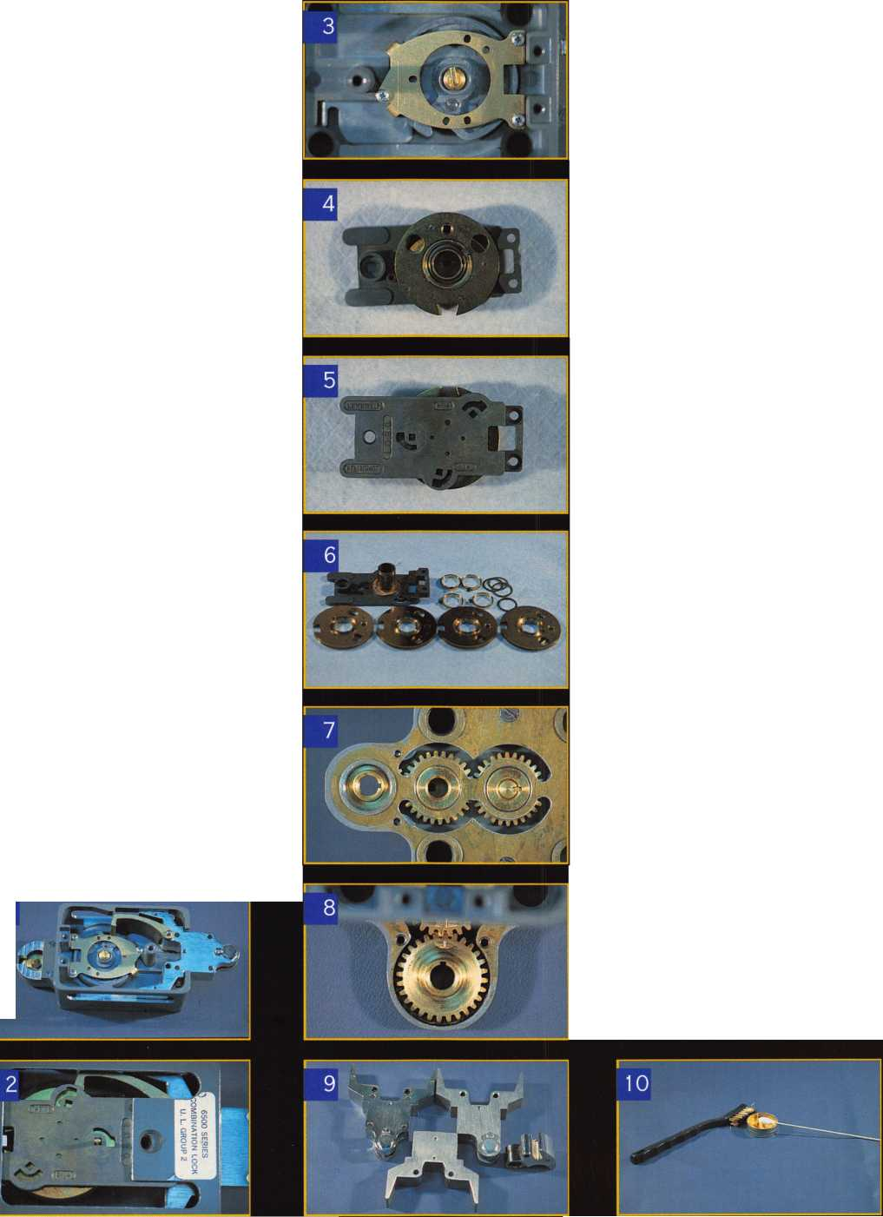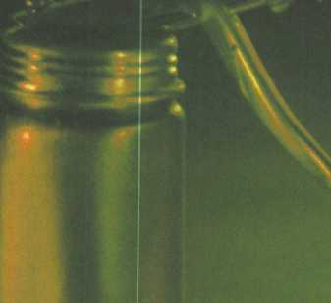

**Safe Lock**



It is rare for locksmiths to concern themselves with mechanics of lubrication. We do not really want to pay attention to terms such as “viscosity” or “metal fatigue.” We have enough trouble trying to keep up with all of the new innovations and tools that are introduced into the profession each and every year! The nice thing about this discussion on safe lubricants and tools is that the methods and items have not changed much over the years. It does not look as if they will make any real big changes for some time to come!

It is also disappointing to realize that many locksmiths are unaware of the simple techniques of safe lock cleaning and lubrication.

I have had opportunities to watch several locksmiths service safes and every one of them choose whatever spray was handy in their service vehicle. Not that this was a bad choice except that every one of those that I witnessed required drilling with repairs to maintain the safe’s serviceability. Each of these occurred within a year of the service work! This is an excellent example of too much of a good thing being disastrous! It is needless to say what this kind of work did for the reputation of the locksmiths concerned. For this very reason, cleaning solvents, lubricants and the right tools to do the job have a place in any discussion of safe servicing.

The items that we will survey here are the ones that I have found useful over the years. I have tried many and even had some made especially for my use, but what is seen and discussed here are those that have been most effective in the more than 27 years that I have spent servicing safes. I shall discuss only those that have worked well. I am also going to restrict this discussion to those items used in the servicing of safes and not to the servicing of bank vaults or safe deposit boxes.

Why Clean and Lubricate Safe Parts?

Metal fatigue is our primary concern for cleaning and for lubrica­tion. As a safe lock is worked through the dial, wear and tear occurs. This fatigue leaves deposits of dirt and metal fragments within the lock. This material then combines with the old lubrication. With this buildup occurs an abrasive action. The grinding action between the metal parts, fowled by the dirt and metal fragments, is so effective that the deterioration of the part’s life span is diminished significantly!

With the above description of metal fatigue, it becomes quite clear that simply spraying more lubrication into the situation will only enhance even further this grinding action and deterioration. Therefore, without complete disassembly of the lock followed by

j

May 1999

241 Keynotes

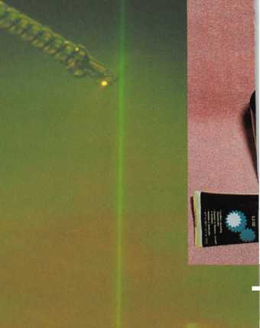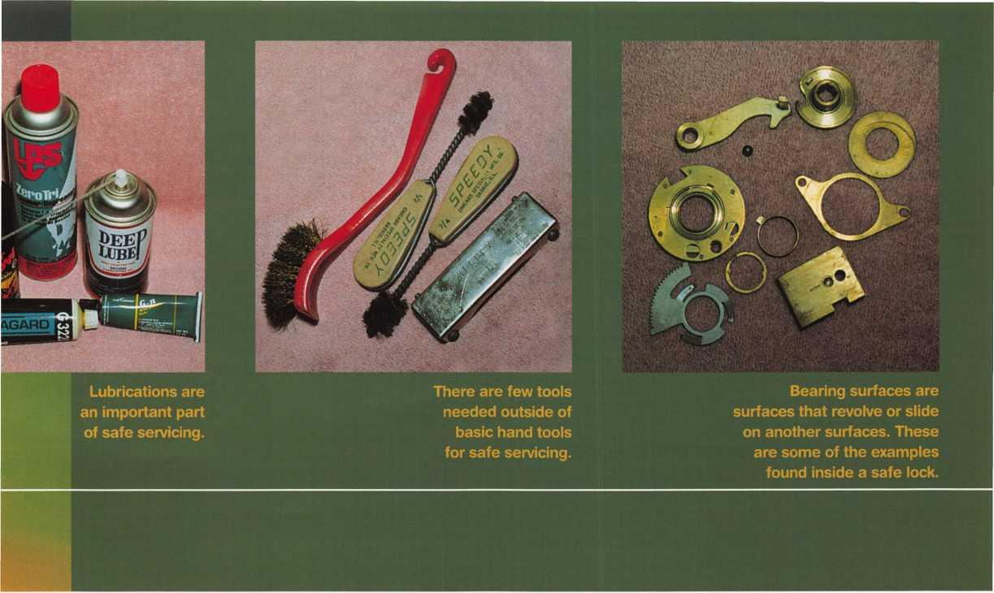

proper cleaning and lubrication, your efforts will be in vain. This is the reason that we need to look at some of the available solvents and lubricants in our quest to provide a professional service.

Solvents

When you use a solvent, you need to remember some important safety considerations: use rubber gloves and work in the open with lots of fresh air. You should also have a first aid kit and lots of water available. Vulcanized rubber gloves are important if you decide to try other solvents than those listed here. You need to remember that they are dangerous in both their fumes and in their ability to burn.

NAPHTHA SOLVENTS: These solvents are quite flammable since they are made from petroleum distillations. They are useful in the removal of most forms of lubrication that will be found in safe work. It is easy to use and has a moderate evaporation rate. Because of its petroleum base it will dry completely without residue and should NEVER be used on plastic parts. Always use these products in metal containers. Glass will work but you can have yourself quite a mess if it drops and breaks. You can find this product in the paint section of your favorite store. A more common name for this product is Paint Thinner!

LPS ZEROTRI: This is a solvent that I have come to use first. It can be purchased at some of the industrial supply houses, some hardware stores will carry it, and some locksmith distributors will also have it in their inventory. It is classified as a heavy-duty penetrating degreaser. I like it simply because it does the job quickly and it does it well. You simply take the spray can that it comes in, point it at the piece to be cleaned and spray away! For safety purposes, wear some rubber gloves and give yourself plenty of ventilation. It contains petroleum distillates as well as ketone.

NON-SUDSING CLEAR AMMONIA: I have to admit that I use this sometimes to simply clear away the crowd. I call it my neutral­izer! We all have the problem from time to time. The individual who is watching is more knowledgeable than the expert is! Out comes the ammonia and away they go. It hasn’t failed me yet! Ammonia is one of the best cleaners and one of the cheapest on the market. It can also be used to clear up the yellow aging of stainless steel as needed. It was my first line of attack until the LPS products came out on the market.

TRI-FLOW: This is a high-grade moderate viscosity lubricant that can be used on bell cranks, and fulcrums. It has little or no ability for penetration. This product can be obtained at some hardware stores and most locksmith distributors.

DEEP LUBE: This is a high-grade moderate viscosity lubricant that can be used on bearings, bell cranks, hinges, and fulcrums.

It is useful in manipulation to smooth out the action of a dial that likes to distract you with a squeaky action. This product has a high degree of penetration capability. I have only seen this product at locksmith distributors.

WHITE LITHIUM GREASE: A low-grade, low viscosity grease lubricant that is inexpensive and has good use for short-term needs. It has little use in safe work. I have used it when I am out of regularly used lubricants. This is rare since I am forced to return to the job to remove it and replace it with the proper lubrication when it arrives from my suppliers. The moral here is don’t run out of the good stuff!

GE llERSILUBE G33221: This is high-grade, low viscosity lubricant grease, which is noted for its ability to last under the rigors of the safe lock. Most safe lock manufacturers recommend it for the

May 1999 Keynotes _U

Lubricants

internal works of their lock mechanisms. The low viscosity keeps it from being used under heavy use such as in heavy machinery. It is superb for safe locks, dials, dial rings, bolts, hinges, bell cranks, fulcrums and whatever else you may wish. The only thing that I find hard to swallow is the price! At just under **$40** a tube, it is used sparingly.

Sparingly is the key word and we will see why a little bit later. There are less expensive lubricants that can cover most of the safe’s needs. I find that Versilube is best kept for the safe lock and dial bearing surfaces only. I have only found this product from Lockmas- ters. I am sure that you may also find it from a GE distributor.

BRAKE GREASE: Brake grease is high viscosity grease that generally is not used except in heavy vault work. I have used it however, on stubborn linkage problems and on hinges on smaller safes. There is generally rust involved and most of the containers have been exposed to outside weather.

G-N METAL ASSEMBLY MSTE BY DOW CORNING: This is high-grade, high viscosity grease that is required to use on U.S. Government lock applications. It is the recommended or required lubrication for Group 1 & 1R locks. It is also a bit pricey but most of us do not have a great deal of government work to do unless you are fortunate enough to have a facility close by.

Lock Cleaning Tools

There is always more than one way to do anything. Beyond the standard hand tools and combination change keys, there are several items that can make safe servicing a simpler task.

STEEL WOOL (EXTRA FINE) AND EMERY CLOTH: These items are used in the cleaning and polishing of safe parts. These are useful are in cleaning residue from bolts or from the matching edges of a money chest lug door. You must remember to clean the wool fragments or grit of the emery cloth from your work. This needs to be done prior to the addition of lubrications. This is one good place to use the LPS spray as a wash to remove the foreign matter.

COTTON TIPPED SWABS & FOAM TIPS: Cotton tip swabs can be found from any drug or grocery store. The foam tip swabs can be found from your local electronics store. For a nasty clean-up job, I would start with LPS spray and then go to ammonia with cotton tip swabs and finish with foam tips. You want to be certain that none of the lint from the cotton tip swabs is left behind. This lint will only hinder proper operation of the lock or linkage. I still use the cotton since it absorbs and holds more cleaning agent then the foam tips seems to be capable of. The foam tips are also more expensive but they work best in dispensing lubrication to crevices inaccessible to the fingertip.

BRUSHES: You need to find several brushes. A small brass bristled brush is needed to clean off grim from bolt works and bell cranks. You also need some plumber’s brushes. These are round steel bristled brushes that you will use to clean out the holes that the bolts slide through. There are two sizes that will serve you well. Find a 1/2 inch brush and a 3/4 inch brush. They were originally used by the plumber to roughen brass fittings before the soldering and fluxing took place.

Servicing Tips

IjOCK CLEANING

Take the time to remove the entire lock from the safe. This is a little extra work but it will allow a complete inspection of the lock and all of the bearing surfaces. Now, disassemble the lock laying all of the parts on a clean surface. Inspect all of the parts and clean with your solvents, insuring to be thorough in your efforts. Next, inspect each bearing surface for burrs or deterioration. Replace parts if they are distorted or in bad repair and use your emery cloth to smooth and polish surfaces. You will want to check the relocker spring tension and its action. Do the same for the fence spring and any other ball bearing and spring combinations that are in the lock. An example of this is under the S&G locking bolt. Once you have completed your inspection and cleaning process, you need to re-inspect all parts to insure that they are dry and free of dirt and lint. Now, they are ready for lubrication.

LUBRICATION

Let me restate an important fret: Too much lubrication can be disastrous. Why? What happens to two flat plates when you cover them with lots of grease and then stick them together? They adhere to one another, right? How would you like to over-grease a tumbler fly? It will stick to one side of the tumbler and not float back and forth in its gate. This simple mistake will give you a lockout and a wish that you had NOT gotten up that morning! Therefore, light lubrication is all that is needed if any at all. Light lubrication is just enough lubricant so that it can hardly be detected by not only the naked eye, but to the touch. Remember, inside of a lock you use light lubrication. On the door locking bolts, bell cranks, handles and dial ring bearings, you can use a heavier amount.

Conclusion

Learning by the lessons of hard knocks is a hard way to accept your fate. If I was to offer the best advice that I could, it would be to take a safe lock course given by your local association or by ALOA at a convention like ALOA ’99 in Cincinnati. Even a correspondence course would be a good idea. No, I am not trying to get you to spend hard-earned money on something that you may or may not need!

Safe work requires communication. If you don’t believe me, then when was the last time a customer called you with a good description of what their problem really was? If we had to rely on what the customer told us, our reputation would lie somewhere between kindergarten and 3rd grade! How are you going to order what you need if you can not identify the parts that you require? How do you expect to get the help you need by telephone if you tell your master safe guru, “Well, the bar thing won’t go into the group of plate things.” I have yet to see anyone become a good safe technician by using only his intuition and good common sense! You need the knowledge, the fastest and cheapest way is with a course! Another way is to apprentice with someone who knows the business.

The only drawback here is the time required.

I know that if this were a safe class, there would be all kinds of questions about your favorite lubricants. Forget about graphite and other oils that were not mentioned here. They will only provide you with troubled experiences that you don’t want or need. The only oil that you may need to use would be three in one oil. Oil in conjunc­tion with emery paper will moisten that paper for a more effective polishing action on parts. Don’t forget to use your solvent to remove the oil and residue deposited by the emery paper. You will find that one-half of all safe lockouts occur from either the lack of lubrication and service, or too much lubrication in the ring and wrong places.

Keynotes

May 1999

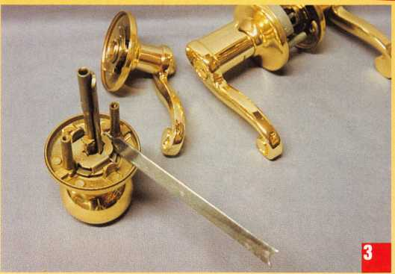

Kwikset has recently introduced new keyed entry levers in three  
different residential designs. Shown in phOtO 1, the Lido lever is the  
mounted lockset in polished brass (US3/ BHMA 605). Below and to  
the left is the Saxton lever in polished chrome (US26/ BHMA 625),  
while the Delta lever design is below and to the right in satin chrome  
(US26D/ BHMA 626). The Lido and Delta levers are available in the  
following finishes: Polished Brass (US3/ BHMA 605), Antique Brass  
(US5/ BHMA 609), Antique Nickel (US 15 A/ BHMA 620), Polished  
Chrome (US26/BHMA 625) and Satin Chrome (US26D/ BHMA  
626). The Saxton lever is available in all the previously mentioned  
finishes except for Satin Chrome.

The new keyed lever handle locks will still install in standard residen-  
tial doors ranging from 1 3/8 inches to 1 3/4 inches thick. Since they use  
standard style residential latches, the standard 2 3/8 and 2 3/4 inch  
backsets also apply. If you can track them down, the 5 inch backset  
latches should also work without any problems. Some older homes will  
sometimes have their entry doors prepped for the 5 inch backset.

If you look at the handle shapes, you may likely come to the  
conclusion that the locks are handed. That is true for the Lido and  
Saxton lever handles (in the middle and to the left). The slightly  
scrolled ends of the lever handles should end in a downward curve, as is  
illustrated. Both these lever styles must be ordered in either left or  
right hand versions. The Delta lever, with its simple straight lever  
handle design is not handed, and can be installed in either left or right  
handed doors. Matching dummy lever handles are available for double  
doors. All of these new keyed lever handle locks are part of the  
“Kwikset Plus” line of products, that provide a five year finish warranty  
and 25 year mechanical warranty.

The Lido lever is not an entirely new design, but the external keyed  
lever is new. The Lido design has been available for some time in the

**May 1999*Keynotes*** ***k***

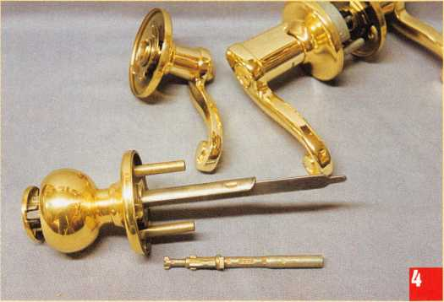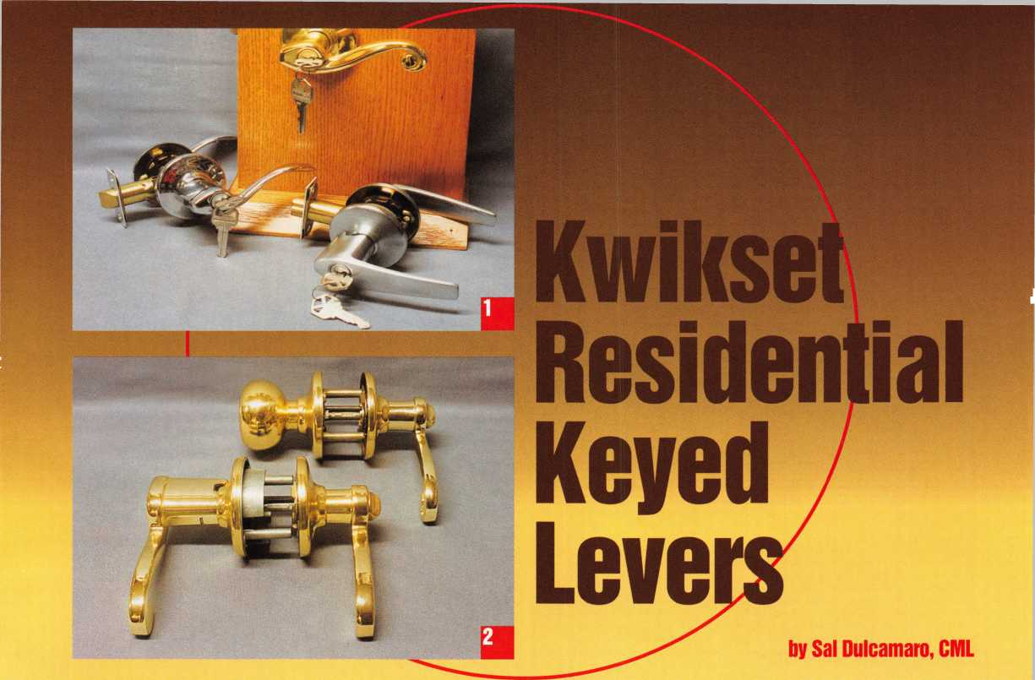

Lock Cylinder Kemovai

From a servicing standpoint, lock cylinder removal is the biggest difference between the original version of the Lido keyed entry lockset and the new design with lever handles on both the inside and outside. It is actually much easier to remove the cylinder on the new design lock, but I will explain both procedures as a means of comparison.

Because the original design Lido keyed entry lock had an exterior knob (rather than a lever), cylinder removal and servicing was identical to servicing other Kwikset entry knob locks. The lock has to be removed from the door in order to remove the lock cylinder properly. PllOtO 3 shows one end of the Kwikset lock cylinder removal tool pushing back a spring loaded shutter to disengage the spindle. With the spindle removed, in photo 4, the other end of the tool enters the opening where the spindle was removed. The “V” shaped end of the tool must engage the two metal prongs (of the lock cylinder) and slightly compress them. When they are squeezed together far enough, the cylinder will disengage and come out of the external knob handle.

You can see the cylinder completely removed in phOtO 5, just above my left hand. Two curved spring steel prongs extend from

passage and privacy functions with lever handles on both inside and out. When it came to the entry function lockset, only the inside lever remained. The outside was switched to a knob style handle to accommodate the standard size residential design lock cylinder.

Photo 2 shows the original design Lido entry lock on top, with the inside handle being the Lido lever design. The outside handle is a knob. Below that lockset is the new design Lido entry lock with lever handles on both sides. The keyed cylinder is in the outside lever handle (at the left side). As a consequence of the design change, you have a much more attractive overall look with a more aesthetically consistent appearance. Another consequence, for the locksmith, is the way the lock is serviced.

I won’t go into details of installation, because the installation procedure is essen­tially identical to all other standard residential Kwikset locks. The latch goes into the edge bore hole and the lock body interconnects through the cross bore hole, followed by attaching the inner handle with two screws. It is very simple with nothing new to learn. The main servicing differences involve removing the lock cylinder.

the back of the cylinder. They normally engage opposing interior surfaces inside the neck of the outer knob to keep the cylinder attached. The “V” shaped end of the cylinder removal tool is just behind the prongs. It is that end of the tool that is used to compress the prongs for cylinder removal. On a standard Kwikset knob, cylinder removal is required for rekeying (or decoding, if keys are lost), and is also needed if the lock handing has to be changed. The knob cylinder can be rotated turn (180 degrees) and reinserted, to change from right to left or left to right handed.

Keyed Entry Lever Cylinder Removal

Like most key-in-lever locks, these Kwikset keyed entry levers have the keyway pointing sideways. As a consequence, there is no need to reorient the keyway position for door handing. Door handing is a concern for both the Lido and Saxton design levers. That is only for ordering purposes, since they are not convertible. The Delta lever is fine for left or right handed doors.

If you look back at photo 5, you will see the Lido design keyed entry lever. Cylinder removal for this Lido entry lock (compared to the original design Lido entry lock) is more

^

Keynotes

May 1999

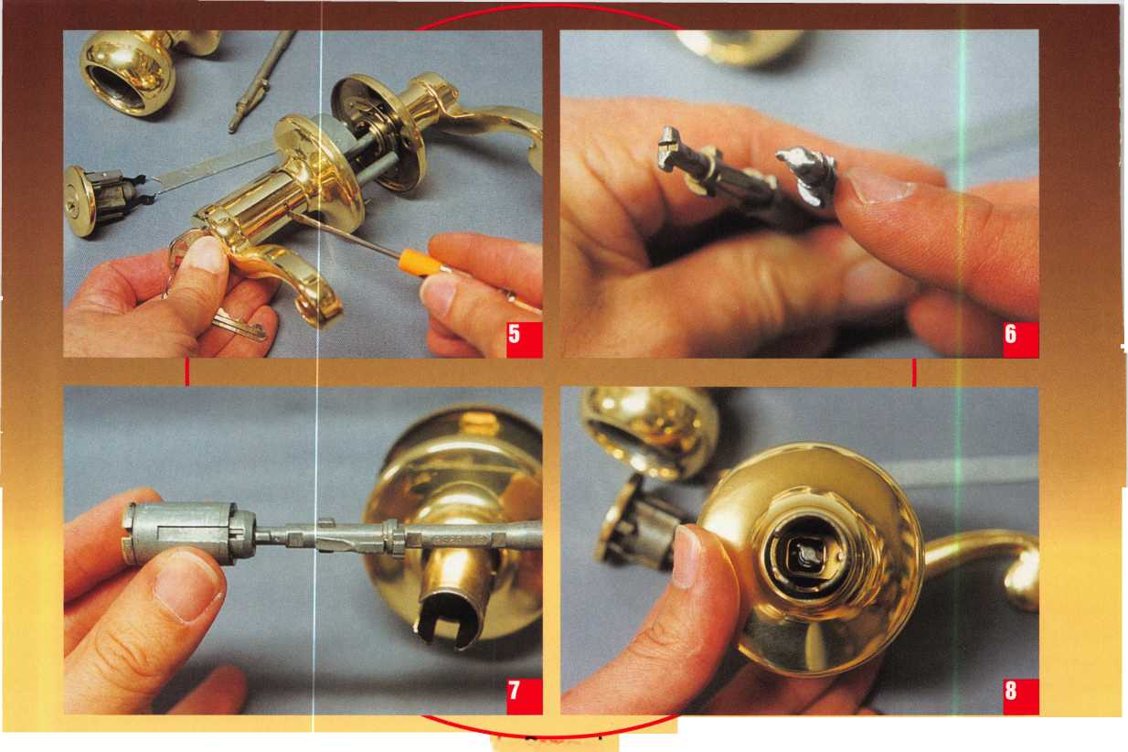

conventional. It is similar, but not identical, to cylinder removal procedures for more typical key-in-knob and key-in-lever (commercial) locksets. In photo 5,1 have rotated the key 1/4 turn counterclockwise, and am pushing in a spring loaded retainer in the neck of the lever handle. This procedure will allow the outer handle to come off, in order to remove the cylinder for servicing. That is where the resemblance (to standard cylinder removal) both begins and ends. First of all, if I had rotated the key clockwise, the retainer would not push inward. Secondly, I don’t actually need a key for cylinder removal.

The key to cylinder removal for the Kwikset residential keyed entry levers is the spindle PhOtO 6 shows a spindle for a knob style entry lock on the left, with a spindle for the keyed lever on the right. The knob lock requires removal of the spindle in order to remove the lock cylinder. The keyed lever does not require the spindle to be removed for cylinder removal. Both locks use the spindle, however, to lock and unlock. I am pointing to a raised surface on the spindle to the right. That surface is used to prevent the retainer from moving inward when the Kwikset keyed lever is in the locked condition.

I have removed the lock cylinder and spindle, in PhOtO 7, to illustrate how the

retainer works. l Kis is a side view, as if you were looking at the lock from the side of the lever handle instead of front face. Obviously, the rest of the lock parts are missing, so that you can see how the internal mechanism works. The lock cylinder is sideways and the tip end of the spindle is engaged with the open end of the cylinder plug (at the back end of the lock cylinder). The raised spot on the spindle protmdes from the right side (in relation to the face side of the lock cylinder).

Photo 8 shows the spindle in the same position, but with the lever handle (and lock cylinder) removed and viewing straight on, instead of a side view. The tip end of the spindle protmdes through the square opening of the retainer. The raised spot on the spindle is directly in the path of the retainer. If a poke tool was used to push in the retainer, the inside opening of the retainer would hit that surface and not move inward enough to release the lever handle.

Again in side view, PhOtO 9 shows the spindle rotated so that the raised spot is now pointing upward and out of the path of the retainer. The spindle can be put in that position by either rotating the key counter­clockwise from the outside, or turning the locking button clockwise from the inside. Photo 10 shows the spindle moved, from a

front view. The raised surface on the spindle is obviously out of the path of the retainer, and the retainer can be easily pushed inward with a poke tool to remove the handle. As I have shown, the key can be used to position the spindle for outside lever handle removal. The only thing necessary, however, is to position the spindle properly. Since the key isn’t required, it is possible to remove the lock cylinder for decoding (when the key is lost).

Photon shows the removed cylinder next to the lever handle. Once the handle is removed, the cylinder comes out from the back side of the lever handle. A side by side comparison of both the knob and lever handle cylinders is shown in PhOtO 12. The knob cylinder is to the left and the lever handle cylinder is to the right. They are rekeyed the same. Either remove the “C” clip and use a key (or pick) to follow out the plug with a plug follower, or remove the pin cover and unload and reload the tumblers from the tops of the pin chambers.

For more information about the residential keyed entry lever locks, contact your lock supplier or Kwikset Corporation at (800) 327-LOCK.

May 1999

Keynotes

^

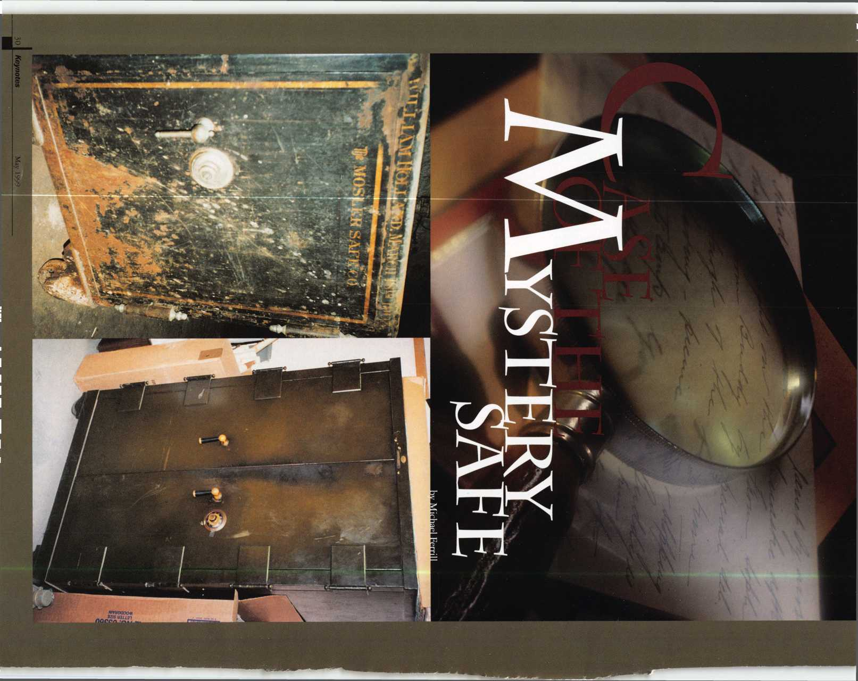

Nantucket Island was once home to the  
largest whaling fleet in the world. With that,  
Nantucket’s men and women returned home  
with different kinds of locks and safes, as well  
as other things of great value to them.

The people from this island have always  
been resourceful and very seldom throw  
anything away. Now, Nantucket is not  
unlike any small community in America  
where perhaps one or two locksmiths live  
and work together. We all receive those  
particular phone calls concerning a special  
lock or perhaps a safe that needs to be open.

One morning early this spring, I received  
such a phone call from Mr. Robert Gardner,  
The Department head of the Wiacomet  
Water Company, here on Nantucket. Bob  
called and asked if I could open a safe that  
was in the back room, that had not been  
opened in some time. Being an optimist  
and someone up to any challenge concerning

locks and safes, I said I would be right  
over. Well, as we all know those words  
are easily said.

I arrived at the Water Company’s main  
building and was ushered into the back  
room. To my surprise, I was introduced to  
the famous “Mystery Safe.” Bob failed to

mention on the  
phone that the safe  
had not been  
opened in the last  
five years and when  
the new addition  
was built, owing to  
the size of the safe  
and weight of this  
safe, the carpenters  
simply built the  
new structure  
around it.

Now to demonstrate my skills as a good  
locksmith, I immediately checked for those  
familiar signs and items that our safe books  
tell us to check for, name of the safe, serial  
number, dial and handle markings and any  
possible factory marks and stampings.  
Nothing could be found, except a small  
metal plate above the doors with the manu-  
facturer’s name. My next recourse was to tell  
Bob that I needed to check with the safe  
specialists in my area, and I would get back  
to him the next day with the answer.

I immediately returned back to my shop  
and began to make a few calls to my fellow  
locksmiths on the mainland. Perhaps one of  
the most important discoveries that I made  
during that research was using the internet

website “ Clear Star Security Network” ([www.clearstar.com](http://www.clearstar.com)). For those of you who are new to the internet or have never used this particular website, it contains several interactive forums that assist the locksmith and security specialist in an assortment areas. I immediately posted a question entitled “Mystery Safe” to my fellow locksmiths, in the “Safe-Tech Forum.” A few hours later, I visited Clear Star again and discovered several responses from Dave LaBarge, Dave McOmie (one of the industry leading experts on safes), Dave Wilson, Chuck Caplinger and Phil Shearer from Lock Defeat Technology in Hanover, MA. The informa­tion that they shared gave me additional confidence, helpful instructions, drill points, manipulation techniques and additional basic information about this particular type of safe.

Armed with this knowledge, I then called Bob back and informed him “we” would attempt to open the safe, the next morning at 9 a.m.

This safe had a small metal stamping above the two metal doors. It identified the safe as being manufactured by the Art Metal Safe Company, located in Jamestown, NY It

was a fire resistant safe, which meant it probably contained shelves within the safe cavity. Because of the two handles, the right door interlocked with the second door when closed. I had previously tried to locate the Art Metal Company in Jamestown, New York, but the company was no longer listed.

I was fortunate enough to troubleshoot myself through the job thanks mainly to the manipulation tips and other information I learned via Clear Star. After opening the safe, I then removed the old lock set. I was prepared to drill the safe open, with the drill points identified, but I am glad that I didn’t because then there would have been repairs involved which might have presented several other problems.

I installed a new ILCO 670 000 series Group II lock, and set the new combination. I thanked Bob for allowing me the opportu­nity to work on his safe and humbly counted my blessings that I was able to provide a service to this company.

In this industry, we are fortunate enough to seek out the help of several experts in this field. Some of these professionals can be referenced through the aforementioned Clear Star or through the Safe and Vault Techni­cians Association (which publishes the infor­mational magazine, Safe & Vault Technology). Resources like these have allowed me the opportunity to gain additional knowledge about these types of situations and can be a benefit to others as well.

Since the ‘Mystery Safe’ venture, I have opened a 1903 Mosler Safe and my experience with safes has continually grown.

Being locksmiths, we must continue to enhance our education through learning and sharing information. ACE classes are an excellent start, but access to a network of security professionals is helpful as well. Of course, these networks are in most of our backyards in the form of local, regional and

state associations as well as our own ALOA.

Without the help of the men and women that I have talked with in this industry and in our association, I would not be the locksmith I am today. So to those people, I say ‘thank you’ for your patience, under­standing and the sharing of knowledge that has helped me become a better locksmith and allowed me to better serve the people of my community.

We all have our own “Mystery Safe” cases to work on, but luckily our resources have grown infinitely. With that, we won’t have to play detective searching for all the right answers and can devote more time being the best locksmiths we can be.

I IMMEDIATELY CHECKED FOR THOSE FAMILIAR SIGNS AND ITEMS

THAT OUR SAFE BOOKS TELL US TO CHECK FOR...

NOTHING COULD BE FOUND, EXCEPT...

May 1999

***Keynotes*** li**i**

**THE SOURCE FOR...**

**Hawkeye... Karl Storz**

**two of the finest names in borescopes**

German optics plus quality construction plus a wide range of sizes  
equals Storz, the leader in industrial visual inspection products.

**See the quality for yourself.**

Visit Timemaster booth 504 for the OFFICIAL unveiling of this revolution  
ary line. Video imaging, light sources, other kits and tools available

**SAFETECH '99 *Convention Specials***

Complete **Hawkeye Kit: fiberoptic straight view probe, 90° mirror tube, light handle,  
carrying case, cleaning kit 7" kit was $590.00** NOW **$520.00**

**12" kit was $690.00** NOW **$608.00**

**17" kit was $760.00** NOW **$670.00**

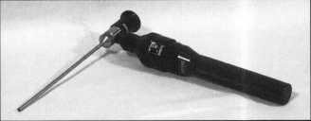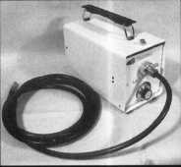

Time-Master.com (web) • [timstr@AOL.com](mailto:timstr@AOL.com) (email)

888 798 8464 / Fax 800 798 TIME (8463) • 785 232

I ASTER . Canada Sales Office: David Bickers 604 944 7129 / Fax 604 944 7248

i» >

niME 888 798 8464 / Fax 800 798 TIME (8463) • 785 232 8705 / Fax 785 232 2603

^ Mi

THERE ARE 50 REASONS WHY YOU SHOULD JOIN US THIS YEAR.



THE FIRST 49 ARE ALREADY OVER. DON’T MISS THIS ONE!

GPL A 50 th Anniversary Convention

September 15u'-19u’, 1999  
Radisson Philadelphia International Airport

Free Clinic

Key Squares Breakfast  
Hands-on Training Classes  
President’s Reception

Product Exhibit  
Lock Picking Contest  
Black Tie Awards Banquet  
Friday Night Social

For Further Information:

Reservations Exhibitors

Jack Magee Don Amole

Phone: 609-384-1538 Phone: 215-288-5588

Fax: 609-845-3024 Fax: 215-288-2511

Or visit our website at: [www.gpla.org](http://www.gpla.org)

Keynotes

May 1999

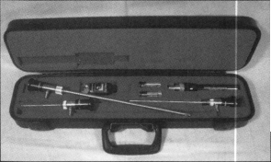

Make Your Mark...

PARTICIPATE IN THE ALOA 1999 ELECTION

It’s election time again! With that, here’s a look at this year’s candidates and their prospective positions. Remember, ballots will be mailed to all members May 29 and they must be received back by July 9.

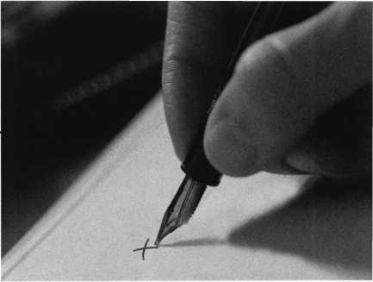

John Cannon, CML **President**

An ALOA member since 1986, John is currently  
serving on the ALOA Board as Secretary. Previously,  
he served as Northeast Vice President of ALOA. He’s  
also been a director and was the chairman of  
Education, Publication, Finance and Personnel

Committees. He has has also served as a member of the SAVTA Board  
of Directors and Chairman of the SAVTA Education Committee. He  
is the owner of Locks Unlimited, Inc. in Alexandria, VA.

James H. Glazier, CML **President**

James H. “Jim” Glazier, CML has been a director  
for ALOA for the past six years and has also served  
on the PRP, Finance, Convention, Education,  
Membership and Library/Museum Committees. He  
has been in the security field for over 40 years, the

past 19 in the locksmithing industry. He owns and operates Security  
Plus Locksmiths in Mount Airy, MD, where he specializes in closed  
circuit TV, access control and high security lock systems. He has  
written numerous technical articles for Keynotes and was chosen as  
“Author of the Year” in 1995. He also has taught the instructor  
training classes and numerous other classes throughout the U.S.

He is a certified instructor for the ACE program.

John J. Greenan **President**

John is the vice president of Fink Safe & Lock Co.  
in Chicago, IL. He represents the fifth generation in  
this family-owned business, which was established in  
1920. John has been active in the industry since 1985  
and has served on the ALOA board for the past six

years. He has instmcted many safe-related classes for ALOA, Greater  
Chicago Locksmiths Association (GCLA) and several other associa-  
tions throughout the United States and Canada. John is a past  
president of the GCLA. He is currently serving as chairman of the  
Allied Locksmiths for Illinois. John is the past chairman of the  
ALOA Legislative Committee and has served on several others  
including the ALOA Strategic Planning and By-Laws committees.

**Mark E. Blum, CML, CPS** Director - Northcentral

Mark is a 39-year locksmithing veteran, a 26-year  
member of ALOA and a certified instructor for 16  
years. Mark has worked in wholesale and retail  
establishments, a university key shop and now an  
independent general practice. He has taught at

ALOA, local and regional locksmith associations, police academies,  
real estate seminars, hospital associations, insurance companies and  
neighborhood watch groups. Mark was the recipient of the first  
ALOA ACE award, in 1990. He currently serves as a director on  
the ALOA board.

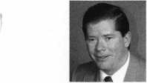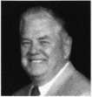

Director - Northcentral

A locksmith since high school in Waunakee, Wis.,  
Tom has been involved with his community’s school  
board, Land Use Planning Commission and serves  
as part-time town constable. He worked at Best  
Access Control as an installer/troubleshooter. He is  
currently employed at University of Wisconsin-

Madison, where he is a locksmith-journeyman.

**John Ilk, CRL** Director - Southwest

John has been a bonded member of ALOA since 1992. He is a  
member of the Grand Canyon Chapter of ALOA and he is presently  
serving as its chairman. He served as the chapter’s Education  
Chairman from 1994-1998. John specializes in safe deposit locks,  
safe combination locks and commercial hardware.

**Gordon Racine, CML** Director - Southwest

Gordon has been an ALOA member since 1982  
and began his career in the security industry in 1980.  
He’s currently serving on the ALOA Board of Directors.  
He owns and operates Racine’s Locksmithing & Security,  
one of the largest security companies in the Lajunta, CO  
area. He provides a security center as well as mobile

locksmith and security service within a 60 mile radius of his business.

**James R. Bamhardt** Director - Southeast

James has been involved with the locksmith  
industry for 24 years. He is a second generation  
locksmith and has been an ALOA member since  
1985. He has been a SAVTA member since 1996.

He specializes in closed circuit TV, as well as access  
control systems. Formerly a convention volunteer in

1998, he currently runs Economy Lock & Key of Brandon, Inc. in  
Brandon, FL.

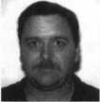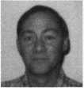

Tom Ripp



**lllle, CML** Director - Southeast

Donald, an ALOA member since 1986, owns and operates Boardtown Locksmith. He is a past presi­dent and life member of the Louisiana-Mississippi Locksmith Association. He is a 1989 convention scholarship recipient and in 1996 was appointed as a member-at-large on the ALOA board. He has served

as a director since 1997. He is currently a member of the ALOA Legislative Action Network. Donald formed a member council solicited by e-mail for interested participants.

**Thomas Tate** Director - Southeast

t

Thomas has been a member of ALOA since 1984.  
After working in Virginia and South Texas, he  
opened American Lock & Key in Pensacola, Fla. He  
was a member of the now-defunct Northwest Florida  
Locksmith Association and served on the board of

SERLAC co-chairing the educational committee. He is currently the  
president of the Florida-Alabama Locksmith Association.

Donald E.

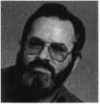

May 1999

Keynotes



A

Keynotes

Classified



Dept

Classified Advertising Policy

**Classified advertising space is provided free of charge to ALOA members, and for a fee of $.60 per word, $15 minimum for non-members. Classified ads may be used to advertise used merchandise and overstocked items for sale, “wanted to buy” items, business opportunities, employment opportunities/positions wanted and the like. Members or non-members wishing to advertise services or new merchandise for sale may purchase a “Commercial Classified Ad,” for a fee of $1.30 per word, with a minimum of $40. Each ad will run for two issues. For blind boxes there is a $5 charge to members and non-members. All ads must be submitted in writing to the ALOA office by the fifteenth of the month, two months prior to issue date. Send to Keynotes Classifieds, 3003 Live Oak St, Dallas TX 75204-6186. ALOA reserves the right to refuse any classified advertisement that it deems inappropriate according to the stated purpose of the classified advertising section.**

■ EMPLOYMENT

Lock & Safe Technicians Needed

5/F/3: King Safe & Lock in Houston is looking to hire experienced and trainee locksmiths. Positions available for dispatcher, inside sales/technician and outside/sales technician. Established 25 year old company with heavy commercial customer base, servicing architectural door hardware, safes/vaults, master-keying and access control. We offer training to qualified applicants who wish to “earn while learning,” to be a professional locksmith. Experienced lock technicians are paid top wages with a benefit package. Medical/ Dental insurance, retirement plan, uniforms, commissions, trucks furnished and professional advanced training. All applicants handled in confidence, private appointments are available. Please send a resume with a recent photo to:

KSL Inc.

8429 Katy Freeway Houston, TX 77024 (800) KINGL0K (713) 463-0824 Fax kinglok@kinglok. com

Locksmiths and Apprentices Wanted

3/F/3: Locks & Keys of Woburn, Mass, seeks self-motivated, reliable individual to perform automotive, commercial and residential locksmith work. We offer a flexible schedule and will train qualified applicants. We are not a family business and you will be compensated for your experience and hard work. All inquiries strictly confidential.

Send resume to:

Locks & Keys, Inc.

P0 Box 222 Woburn, MA 01801

Locksmith Wanted

5/F/3: California $30-60K plus benefits. Two years experience minimum. Send or fax resume to:

Speedy Locksmiths Inc.

2317 N. Main Street Walnut Creek, CA 94396 (923) 933-9010 (923) 280-7274fax

A *Keynotes*May 1999

Commercial Locksmith Wanted

5F/3: Located in the middle of Gods country, Charlotte, NC. Were a growing progressive, ethical, established and well financed 29 year old, second generation distributor of hollow metal, wood doors and finish hardware.

Were seeking a Locksmith/Key Records Manager. Individual shall be professional, organized, familiar with different commercial lock manufacturers’ products and capable of generating Key Systems and Key Schedules according to industry standards. AHC or CML preferred but not required. Competitive salary with bonuses, medical insurance, 401K, profit sharing and relocation assistance. Send resume with requirements in confidence to:

Mark S. Burgess, AHC Burgess Sales & Supply, Inc.

2121 West Morehead Street Charlotte, NC 28208 (704) 333-8933 (704) 333-6321 fax

Safe Technicians Needed

3/F/3: Get lucky and work in booming Las Vegas. Great work environment. Great weather, great income potential for experienced, motivated, hardworking technicians and team players. Paid holidays, vacation, medical, 40IK plan and in-house training. Don’t delay. Fax your resume today. Fax resume to:

Liberty Lock and Safe (702) 876-3470 or send to:

3470 W. Sahara Ave.

Las Vegas, NV 89146 website: [www.libertylock.com](http://www.libertylock.com)

Experienced Locksmith Wanted

3/F/3: Well established Houston company seeking an experienced Locksmith with tools and a vehicle. Excellent pay, commissions, paid vacations and bonuses.

Call: (281) 497-3333 or (713) 266-4330

Commercial Locksmith Wanted

3/F/3: Experienced commercial Locksmith wanted for the Southern California area.

Large commercial based locksmith and door company is seeking experienced locksmiths with a minimum of two years of field experience. Safe experience helpful and

vehicle and tools provided. Benefits include excellent pay, profit sharing, medical and dental, paid holidays and vacation. This will be the last job of your career. Immediate openings. Only qualified candidates.

Fax resume to: (800) 804-0063 or call: Bob Madsen at (362) 862-1782

Locksmith Wanted

3/F/2: Work for a 24 year-old company in the Great Northwest. Excellent salary with a 401K, paid holidays, health insurance and immediate vacation accruement. Door hardware knowledge required. Storefront and hollow metal door experience a plus.

No auto experience required. Lucrative after hours work optional. Must have good communication skills, professional attitude and a clean driving record.

Send resume to:

The Lock Shop 31008 Pacific Hwy S.

Federal Way, WA 98003 (233) 839-3443

or fax to: (206) 946-6143

Locksmith Wanted

3/F/3: Broward Century Locksmiths Inc. is seeking motivated technicians! Positions available for inside and outside technicians. We are a progressive full service locksmith and electronic security company specializing in commercial, residential, safes and access control (no automotive). We are located in southeast Florida with two locations and excellent working conditions. We provide paid health insurance, vacations and holidays. Experience with access control and safes a plus, but not necessary. If interested in joining our team, sent resume to:

Broward Century Locksmiths, Inc.

Attn.: Mike Sullivan 3 7 Northeast 2nd Avenue Deerfield Beach, FL 33441 (954) 427-7008 Fax: (934)427-7030 Mike@browardcentury. com

Manager Wanted

3/F/3: Six person shop needs a Locksmith with excellent understanding of the industry and desire to help manage the shop. Located in beautiful downtown Portland, the shop specializes in high security hardware. Low-

voltage experience and computer skills a plus. Candidate must be responsible and enjoy working with people. Must have personal tools and some after hours work required. Salary range is from 28 to 34K. Benefits also include a retirement plan.

Send resume to:

Neal McMahon McMahon’s Locksmiths 401 W. Burnside Street Portland, OR 97209-3817

M SITUATION WANTED Locksmith for Hire

3/F/3: Bonded locksmith, deadbolts, alarms, locks installed, cylinders, rekeyed, house locks keyed alike.

Call: Joseph Musac (316) 822-3903

■ BUSINESSES FOR SALE Business For Sale

5/F/3: Well established locksmith business, with many commercial and industrial accounts make this a very successful operation. Established in 1986, we have continued to grow reaching a $135K plus gross. Located in south-central North Carolina near good fishing, hunting and recreational areas. This community is growing, with a very strong base of banking, large office complexes, myriad of industrial sites and a state university. Our service area includes the surrounding counties. This is a great opportunity for the right “Go-Getter,” as instant growth is possible by adding residential and automotive service to our established commercial client base. Owner wants to retire but will stay on to smooth the transition. Price includes 1995 Dodge Maxievan-fully equipped and has 4K Onan genset and 1 IK BTU roof air, as well as all office equipment, including several computers. Asking $150K. Serious inquiry only-please. Contact:

Ray R Whitehead, CML American Safe & Lock 8301 Cedarbrook Drive Charlotte, NC 28213 (704) 363-9067 (704) 363-0134fax

Business For Sale

5/F/3: Trenton-Princeton, NJ. Rt. 1 Corridor. Gross 175K, two person.

Locks, alarms, showroom, two vans with great potential. $185K with real estate, but will separate. Contact Jim Blake or fax your bid to:

Jim Blake

Blakes Locksmiths Security Inc.

1664 East State Street Trenton, NJ 08609 (800) 228-1268 (609) 386-2716fax

Portable Locksmith Shop

3/F/3: Keys, key machines, locks and supplies $32,000 delivered. Includes 30,000 keys, dimple machine, 1200 dialer, lever lock, safe rig, code books, Kwikset, auto, pin kits, high security machine, locks, clippers, IC punch, 10 key machines. Includes help starting your own mail order/internet business video.

Call Randy: (800) 332-1773.

Complete Mobile Shop

3/F/3: Buy today and start making money tomorrow. 1996 Ford E250 white van,

1. miles. Includes AM/FM cassette, cruise control, A/C, Medeco ignition, steel bulk head, insulation, paneling on the walls, and an amber emergency light on top. Mobile phone, two way radio, 110 Vac lighting with a Honeywell 1600 watt generator, HPC 1200 CM and 025 duplicator, 003 Lab pin kit, Formica counter top workbench, Weather Guard metal cabinets, Craftsman Bench vise, manual credit card imprinter, All-Lock a 7000 Vats decoder, A1 GM 10 cutting tool kit, 1/4" steel letter and number stamps. Snap-On Magnetic tool strips. Complete set of ProLok car opening tolls and books. $45,000. Must sell! Serious inquiries only.

Call: (913) 330-3397.

■ WANTED TO BUY/SELL Keys for Sale

5/F/3: 700 pair pre-cut Schlage original keys. Best offer.

Call: (213) 331-3286

Locksmith Tools and More For Sale

5/P/2: Locksmith tools, supplies, machines, two Curtis Automotive Code Cutters, Code books and safe tools. Depth key sets and over

1. automotive and domestic keys. $18,500 firm.

Contact: John M. Merry P. 0. Box 728 Dereby, NY 14047-0728 (716) 349-3439

Time Lock Specialist

5/P/2: Experienced Safe and Lock Technician servicing all makes and models of time locks since 1983. Go after that business you’ve had to shy away from. You pull and ship the clock, we repair/service it and ship it back for you to re-install.

Contact: The Clockworks (362) 690-9967

Chicago Lock Wanted

5/F/3: Looking for Chicago Lock #42l4A, double-prong Ace desk type lock, used on police call boxes. Requesting quantity and price.

Call: E. Kostelaz (Gem)

(806) 332-2137

Reed Code Books Wanted

5/F/3: Locksmith looking for Reed code books. Have some volumes, but looking for others.

Contact: August Gomes Gus The Locksmith P 0. Box 1219 West Warwick, RI02893 (401)821-1834 [LOCK3MlTH@aol.com](mailto:LOCK3MlTH@aol.com)

Items For Sale

3/F/3: A-l PAK3, Auto key punch with case and A-l PAKCL Chrysler, A-l PAKG1, GM Multi-Purpose, A-l PAKF1 Ford 10-cut. Paid $586.00 or best offer.

Respond to:

2820 LaPlant Rd.

Grand Rapids, Minn. 33744

Invention for Sale

3/F/3: Heavy Duty sliding-door lock, patented in the U.S. and Canada. Can be fitted with single or double cylinders for key operation on both or either side. Can be keyed to most cylinders in the market. Prototype available.

Call: (230) 763-7388 (230) 763-7332 fax

Code Machine For Sale

3/F/3: ITL 950 code machine, nearly new (3/98) in box with all manuals and instructions. Very light use. Use either 12 or 120 volts. $1,550. Currently relocating business.

Leave message for: Mike (978) 276-1811

Best Items Wanted

3/F/3: Searching for any old or current original Best items - logo, padlocks, keyblanks, cores, key machines, etc.

Contact: Richie Sommers!Above All Locksmiths (718) 671-3227

Van For Sale

3/F/3: 91 Aeromate walk-in Van, custom and Adrian steel cabinets, custom lighting, upgraded alarm system, HPC 1200 Code Machine, HPC **44**4**4** Copier (copied less than 1000), Redi-Line converter, only 39,000 miles. Just move in your tools and go to work! $13,500.

Call: (949) 438-7439

Safe Manual

3/F/3: Fichet-Bauche Safe Manual wanted urgently by Irish ALOA member.

Call: Basil Shannon (333) 348-3328 or fax: (333) 348-3301

**May 1999 Keynotes 111**

Associate

Members

|  |  |
| --- | --- |
| Manufacturers | Arrow Lock Company  10300 Foster Avenue  Brooklyn, NY 11236 (718) 257-4700; FAX (718) 649-9097 |
|  | • • • • |
| A & B Safe Corp.  171 S. Delsea Dr.  Glassboro, NJ 08028 (800) 253-1267; FAX (609) 863-1208 | Auto Security Products (A. S. P.)  P.0. Box 10  Redmond, WA 98073-0010 (425) 556-1900; FAX (425) 558-1205 |
| • • • • | • • |
| ASSA Inc.  10300 Foster Ave.  Brooklyn, NY 11236  C800) 235-7482; FAX (718) 257-2772 | BWD Automotive  900 Ravenwood Dr.  Selma, AL 36701  (334) 874-9001; FAX (334) 874-6011 |
| • | • • |
| Abus Lock Company  3555 Holly Lane North  Plymouth, MN 55447-0507 (800) 352-2287; FAX (612) 509-9939 | Chicago Lock Company  10100 88th Ave.  Pleasant Prairie, Wl 53158-0069 (800) 445-3204; FAX (414) 947-7178 |
| e | i |
| Adams Rite Manufacturing Co.  P.0. Box 1301  LaPuente.CA 91749-1301 (562)699-0511; FAX (562) 699-5094 | Corbin Russwin Architectural Hardware  P.O. Box 25288  Charlotte, NC 28229 (800) 543-3658; FAX (800) 447-6714 |
| • • • • | • • • • |
| Adesco Safe Manufacturing Co.  web: [www.adesco.com](http://www.adesco.com) email; [sales@adesco.com](mailto:sales@adesco.com) (800) 821-6803; FAX (562) 408-6427 | Curtis Industries  6140 Parkland Blvd, Ste. 300  Mayfield Heights, OH 44124-4103 (800) 555-5397 |
| • | • • |
| Adrian Steel Company  web: [www.adriansteel.com](http://www.adriansteel.com)  Adrian, Ml 49221  (800) 677-2726; FAX (517) 265-5834 | DETEX  302 Detex Dr.  New Braunfels, TX 78130 (800) 729-3839; FAX (830) 620-6711 |
| e | • • • • |
| Alarm Lock Systems, Inc.  345 Bayview Ave.  Amityville, NY 11701 (800) ALA-LOCK; (516) 789-3383 | Don-Jo Manufacturing, Inc.  P.O. Box 929  Sterling, MA 01564 (508)422-3377; FAX (508) 422-3467 |
| • | • • |
| Aiphone Intercom Systems  1700-130th Avenue, NE  Bellevue, WA 98005 (425) 455-0510; FAX (425) 455-0071 | Door Controls International  2362 Bishop Circle East  Dexter, Ml 48130  (800)742-3634; FAX (800) 742-0410 |
| ^ <3^ (0 | 9 9 9 4$ |
| American Lock Co.  3400 West Exchange Road  Crete, IL 60417-2099 (708) 534-2000; FAX (708) 534-0531 | ESP Lock Products, Inc.  375 Harvard Street  Leominster, MA 01453 (978)537-6121; FAX (978) 534-9109 |
| • e | • • |
| American Security Products (AMSEC)  11925 Pacific Ave.  Fontana, CA 92337-6963 (800) 423-1881; FAX (909)685-9685 | Folger Adam Security, Inc.  16300 W. 103rd Street  Lemont IL 60439  (630) 739-3900; FAX (630) 739-6138 |
| • • | e e |
|  |  |



Associate members of the Associated Locksmiths of America (ALOA) manufacture or distribute materials or equipment, or provide services, for the security industry. Many have donated money, services and equipment to ALOA in addition to their annual dues. Their support of ALOA projects enhances overall membership benefits and we encourage our members to patronize these firms. If you know of a potential candidate for associate membership, please contact the ALOA Membership staff at (800) 532-ALOA. Associate member dues are $500 per year and entitle the payor to use the ALOA logo, and selected discounts on ALOA products and services.

Legend

9 Alarms: Personal, vehicle, electronic, fire, burglar, and exit

9 Automotive: Lockout equipment, key chains/rings

9 Builders Hardware: Door closers, furniture/decorative hardware, viewers, emergency exit devices

Books, reference guides, publications, computer software

9 CCTtf/Photo Imaging: Cameras, monitors, photo ID equipment, cables

9 Electric/Electronic Security: Card access control and readers, surveil­lance, electric/magnetic locks and strikes, keypads

9 Lock Devices: Auto locks, cylinders, emergency exit/entrance control, locks (various types), strikes

9 Tools & Supplies: Key blanks, cutters, picks, rings/hooks, custom van/truck supplies



i

I

**361 *Keynotes***

**May** 1999

|  |  |  |
| --- | --- | --- |
| Fort Lock Corp.  3000 N. River Rd.  River Grove, IL 60171 (708) 456-1100; FAX (708) 456-9476 | La Gard, Inc.  3330 Kashiwa Street  Torrance, CA 90505 (310) 325-5670; FAX (310)325-5615 | Sargent & Greenleaf, Inc.  P.O. Box 930  Nicholasville, KY 40340-0930 (606) 885-9411; FAX (606) 887-2057 |
| •••••• | 9 9 9 | 9 9 9 9 |
| Grobet File Co. of America  750 Washington Ave.  Carlstadt, NJ 07072  C800) 962-7242; FAX (800) 243-2432 | Lucky Line Products  7890 Dunbrook Rd.  San Diego, CA 92126 (619) 549-6699; FAX (619) 549-0949 | Schlage Lock Co.  1915 Jamboree Suite 165  Colorado Springs, CO 80920 (800) 847-1864; FAX (800) 452-0663 |
| • | • | • • |
| H.E.S., Inc.  2040 W. Quail Ave.  Phoenix, AZ 85027 (602) 582-4626; FAX (602) 582-4641 | M.A.G. Engineering & Mfg. Inc.  15261 Transistor Lane  Huntington Beach, CA 92649 (714) 891-5100; FAX (714) 892-6845 | Schwab Corporation  110 Professional Court  Lafayette, IN 47905 (765) 447-9470; FAX (765) 447-8278 |
| • • • | 9 9 9 | • |
| HPC, Inc.  3999 N. 25th Avenue  Schiller Park, IL 60176 (847) 671-6280; FAX (847) 671-6343 | MARKS USA  5300 New Horizons Blvd.  Amityville, NY 11701 (516) 225-5400; FAX (516) 225-6136 | Securitron Magnalock Corp.  550 Vista Blvd.  Sparks, NV 89434  (800) 624-5625; FAX (702) 355-5636 |
| • • • | • | 9 9 |
| HID Corporation  9292 Jeronimo Road  Irvine, CA 92618  (949) 568-1600; FAX (949) 568-1680 | MUL-T-LOCK USA, Inc.  300-1 Route 17 South Suite A  Lodi, NJ 07644  (800) 562-3511; FAX (973) 778-4007 | Security Door Controls  3580 Willow Lane  Westlake Village, CA 91361 (805) 494-0622; FAX (800) 959-4732 |
| • • | • • 9 | • |
| llco Unican  400 Jeffreys Road  Rocky Mount NC 27804 (252) 446-3321; FAX (252) 446-4702 | Master Lock Company  2600 North 32nd Street  Milwaukee, Wl 53211 (414) 444-2800; FAX (414) 449-3114 | Security Solutions  1640 W. Hwy. 152  Mustang, OK 73064 (405) 376-1600; FAX (405) 376-6870 |
| ••••••• | • • | • • • |
| In Out Systems, Inc.  3650-B Matte Boulevard  Brassard, Quebec J4Y-2Z2, Canada (450) 444-5949; FAX (450) 444-4856 | Medeco Security Locks  P.O. Box 3075  Salem, VA 24153  (540)380-5000; FAX (540) 380-5010 | Sentry Group  900 Linden Ave.  Rochester, NY 14625-2784 (716) 381-4900; FAX (716) 381-8559 |
| • • | • • 9 | • |
| Intellikey  551 S. Apolo Boulevard, Suite 204  Melbourne, Florida 32901 (800) 226-0703; FAX (407) 724-0811 | Meilink Safe Company  111 Security Parkway  New Albany, IN 47150 (800) 634-5465; FAX (800) 896-6606 | Sully Tools Inc.  3515 Nodding Pine Ct.  Fairfax, VA 22033  (703) 689-3416; FAX (703) 787-0869 |
|  | • | 9 9 9 |
| KABA High Security Locks  P.O. Box 490  Southington, CT 06489 (860) 621-3601; FAX (860) 621-9727 | National Cabinet Lock  200 Old Mill Road, P. 0. Box 200  Mauldin, SC 29662 (864) 297-6655; FAX (864) 297-9987 | Taymor Industries, Inc.  1586 Zephyr Ave.  Hayward, CA 94544 (800) 388-9887; FAX (800) 288-8133 |
| • | • | 9 9 |
| KEY-BAK; Div. of W. Coast Chain Mfg. Co.  1460 S. Balboa Ave.  Ontario, CA 91762 (909) 923-7800; FAX (909) 923-0024 | Newman Tonks  805 N Buckman St.  Shepardsville, KY 40165 (800) 826-5792; FAX (800) 777-8229 | Trine Products Corporation  1430 Ferris Place  Bronx, NY 10461  (718) 829-4796; FAX (718) 792-9127 |
| • • • • | • 9 | 9 9 9 |
| Knaack Manufacturing Co.  420 E. Terra Cotta Ave.  Crystal Lake, IL 60014 (800) 456-7865; FAX (815) 459-9097 | ROFU International Corp.  2004-B 48th Ave.; Court E  Tacoma, WA 98424 (800) 255-7638; FAX (253) 922-1728 | W-Lok Corporation  675 East 16th Street, Suite 111  Holland, Ml 49423 (616) 355-4015; FAX (616) 355-4295 |
| • | 9 9 9 | • |
| LAB Security  700 Emmett St.  Bristol, CT 06010  (800) 243-8242; FAX (203) 583-7838 | Rutherford Controls Inc.  2697 International Pkwy, Bid 5 #100  Virginia Beach, VA 23452 (757) 427-1230; FAX (757) 427-9549 | Weiser Lock Company  6700 Weiser Lock Blvd.  Tucson, AZ 85746  (502) 741-6338; FAX (520) 741-6363 |
| 9 | • | • 9 |
| LCN Closers (Division of Ingersol)  121 W. Railroad Ave.  Princeton, IL 61356 (815) 875-3311; FAX (815) 875-3222 | STRATTEC Security Corp.  3333 W. Good Hope Rd.  Milwaukee, Wl 53209 (414) 247-3333; FAX (414) 247-3329 | Yale Security Inc.  P.O. Box 25288  Charlotte, NC 28229-8010 (800) 438-1951; FAX (800) 338-0965 |
| • | 9 9 9 | 9 9 9 9 |
|  |  |  |

May 1999

Keynotes

|  |  |  |
| --- | --- | --- |
| Zhongshan Hua Feng Lock Products  S Yongning industrial Road, Ziaolan Zhongshan Guangdong, China  86-760 227 82 63; FAX 86-270 227 80 63  e | Direct Security Supply, Inc.  36 Lincoln Street  Boston, MA 02135 (800) 252-5757; FAX (800) 452-8600  ^ (§}) (|^ (0 ^ | IDN, Inc.  1000 S. Main, Suite 280  Grapevine, TX 76051 (817)421-5470; FAX (817) 421-5468 |
| Distributors | Doyle Lock Supply  2211 W. River Road N.  Minneapolis, MN 55411 (800) 333-6953; FAX (612) 521-0166 | Intermountain Lock & Supply Co  3106 South Main Street  Salt Lake City, Utah 84115 (800) 453-5386; FAX (801) 485-7205 |
| Accredited Lock Supply Co.  P.O. Box 1442  Secaucus, NJ 07096-1442 (800) 652-2835; FAX (201) 865-5031  (^| @ <0 (Q ^ | Dugmore & Duncan Inc.  30 Pond Park Rd.  Hingham, MA 02043 (888) 384-6673; FAX (888) 329-3846  ••••••# | JLM Wholesale, Inc.  3095 Mullins Ct  Oxford, Ml 48371-1643 (800) 522-2940; FAX (800) 782-1160  • • • |
| Ace Lock & Security Supply Co.  565 Rahway Ave.  Union, NJ 07083-6631 (800) ACE-LOCK; (800) ACE-FAX4  •••••••• | E. L. Reinhardt Co., Inc.  3250 Fanum Road  Vadnais Heights, MN 55110 (800) 328-1311; FAX (612) 481 -0166 | Jo-Van Distributors Inc.  929 Warden Ave.  Scarborough, Ontario MIL 4C6 (416) 752-7249; FAX (416) 752-3845  ••••••••••• |
| Akron Hardware Consultants, Inc.  2579 South Arlington Road  Akron, OH 44319  (800) 321-9602; FAX (800) 328-6070  see | Ewert Wholesale Hardware  4709 W 120th St  Alsip II 60658  (800) 451-0200; FAX (708) 597-0881  • • • • • | Lockmasters, Inc.  5085 Danville Road  Nicholasville KY, 40356 (800) 654-0637; FAX (606) 885-7093  • • • • |
| American Security Distribution  4411 E. La Palma  Anaheim, CA 92807 (714) 996-0791; FAX (714) 579-3508  • •••••• | Fairway Supply, Inc.  2631 Lombardy Lane  Dallas, IX 75220  (214)350-0021; FAX (214) 352-4299  (01 @ <£) (£} ^ | Locks Company  2050 N.E. 151 St.  N. Miami, FL 33162 (800)288-0801; FAX (305) 949-3619  ••••••• |
| Andrews Wholesale Lock Supply  544 S. 9th St.  Lebanon, PA 17042-6608 (717) 272-7422; FAX (717) 274-8679  • | Foley-Belsaw Company  6301 Equitable Road  Kansas City, MO 64120 (800)821-3452; FAX (816) 483-5010  • e • • | The Locksmith Store Inc.  1229 E Algonquin Rd. Suite E  Arlington Heights, IL 60005 (847) 364-5111; FAX (847) 364-5125  • • • • |
| Boyle & Chase Inc.  P. O. Box 74  Accord, MA 02018-0074 (800) 325-2530; FAX (800) 205-3500  © © • | Fried Brothers, Inc.  467 N. 7th St.  Philadelphia, PA 19123 (800) 523-2924; FAX (800) 541-3489  •eeeeeeee# | M. Zion Company  69 Reade Street 4th Floor  New York, NY 10007 (212) 349-8677; FAX (212) 964-0495  ^ @ © © © © |
| Clark Security Products, Inc.  4775 Viewridge Ave.  San Diego, CA 92123-1641 (800) 854-2088; FAX (619) 974-5284 | HS&S Wholesale Distributors  12915 West 8 Mile Road  Detroit Ml 48235  (800) 521-2202; FAX (313) 342-7580  ••••••• | McDonald-DASH Locksmith Supply  5767 E. Shelby Dr.  Memphis, TN 38141 (800) 238-7541; FAX (901) 366-0005  •••••••• |
| Cook’s Building Specialties  2441 Menaul Blvd. NE; P.O. Box 37320 Albuquerque, NM 87176-7320 (505)883-5701; FAX (505) 883-5704  •••••• | Hans Johnsen Company  8901 Chancellor Row  Dallas, TX 75247  (214) 879-1550; FAX (214) 879-1530  •••••••• | McManus Locksmith Supply, Inc.  P.O. Box 9231,1309 Central Ave.  Charlotte, NC 28299 (702) 333-9112; FAX (704) 332-8664  •••••• |
| DiMark International  3117 Liberator St., Unit A  Santa Maria, CA 93455 (800) 235-2435; FAX (805) 928-8034  ^ | Hardware Agencies, Ltd.  1220 Dundas Street East  Toronto, ON M4M 1S3 (416) 462-1921; FAX (414) 462-1922 | McMaster-Carr Supply Company  600 County Line Rd,  Elmhurst, IL 60126-2081 (630) 833-0300; FAX (630) 834-9427  •••••• |
| Dire’s Lock & Key Co.  2201 Broadway  Denver, CO 80205  (303) 294-0176; FAX (303) 294-0198  ••••••••••• | Hardware Suppliers of America  P.O. Box 2208  Winterville, NC 28590 (800) 334-5625; FAX (800) 334-5635  • ® | Monaco Lock Co.  339-345 Newark Ave.  Jersey City, NJ 07302 (800) 526-6094; FAX (800) 845-LOCK  (j) (0 |
|  |  |  |
| © Alarm © Business/Tech & Ed. © Tools & Supplies  © Bank Security Equipment © CCTV/Photo Imaging © Safes/Vaults  © Automotive © Electric/Electronic Security © Other  © Builders Hardware © Lock Devices | | |

Keynotes

May 1999

|  |  |
| --- | --- |
| Omaha Wholesale Hardware  1201 Pacific Street, PO Box 3628  Omaha, NE 68108 (800) 238-4566  @ |g}| @ (0 ||(jj | U.S. Lock Corporation  77 Rodeo Drive  Brentwood, NY 11717 (800) 925-5000; FAX (800) 338-5625  <gj) @ (£) (g g| |
| Security Lock Distributors  40 A Street  Needham Heights, MA 02194 (800) 847-5625; FAX (800) 878-6400  |gj| <0 ^ | Webster Safe & Lock Company, Inc.  3020 Millbranch  Memphis, TN 38116 (901) 332-2911; FAX (901) 332-2878  ® g) @ (gj (gj g g |
| Sentry Security Fasteners  8109 N. University  Peoria, IL 61615  (309) 693-2800; FAX (309) 693-2872 | Service |
| Southern Lock and Supply Co.  Box 1980, 10910 Endeavor Way  Pinellas Park, FL 33780 (800) 237-2875; FAX: (800) 447-2299 | Alarm Monitoring Service, Inc.  5021 Fairfield St.  Metairie, LA 70006 (504) 454-2163; (504) 456-8737  @ |
| Stone & Berg Wholesale  99 Stafford Street  Worcester, MA 01603 (800) 225-7405; FAX (800) 535-5625 | Allstate Insurance Company  2775 Sanders Road, Suite A5  Northbrook, IL 60062 (847) 402-8196; FAX(847) 326-7509  @ |
| Strauss Safe & Lock Company  1801 Second Avenue  Des Moines, IA 50314 (515)288-9571; FAX: (515)288-9752  ® (0 ® (jj $ | Diamond Software  2952 N. Expressway  Griffin, GA 30223  (770) 227-7650; FAX (770) 227-1699  @ |
| Timemaster, Inc.  127 SE 29th Street  Topeka, KS 66605  (785) 232-8705; FAX (800) 798-8463  (gj (g^ (0 (g) g | Locksmith Publishing Corp.  850 Busse Hwy.  Park Ridge, IL 60068 (847) 692-5940; FAX (847)692-4604  © |
| Top Notch Distributors, Inc.  3151 Goni Rd.  Carson City, NV 89706-7922 (800) 722-4210; FAX (800) 248-3620  (gj> (|J (g) | The National Locksmith Magazine  1533 Burgundy Parkway  Streamwood, IL 60107 (630) 837-2044; FAX (630) 837-1210  © |
| Turn 10  P. O. Box 746  Marietta, OH m45750 (800) 848-9790; FAX (800) 391-4553 | Pine Technical College  1000 4th Street  Pine City, MN 55063 (800)521-7463; FAX (320) 629-7603  © |
|  |  |

|  |  |  |  |
| --- | --- | --- | --- |
| <«5  O  £  &  * | ss Advertisers Index | |  |
| Advertiser | Page | Advertiser | ^ y' * i 1 |
| A&B Safe | 12 | Locksmith Ledger _ | IBC |
| ALOA ’99 | BC | SAFETECH ’99 | IFC |
| BWD | 43 | Sargent & Greenleaf _ | 6 |
| Fireking/Meilink | 19 | Stone & Berg | 9 |
| GPLA | 32 | Timemasters | 32 |
| lico Unican | 1 | UPP | 15 |
| KSP | 43 |  |  |

It pays

to have new faces  
in the crowd.



During 1999  
each ALOA member  
who sponsors  
a new applicant  
will receive $40 in  
Convention Bucks  
(upon clearance,  
and payment of  
application fee and dues).

May 1999

Keynotes

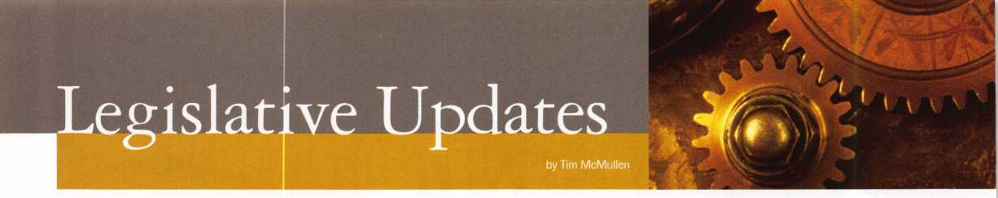

BUSY’S NOT THE WORD!!!

• Overwhelmed would be the word to use in describing this year’s legislative onslaught. Currently, ALOA is closely tracking 25 bills affecting the security industry. Most deal with locksmithing, with only a few alarm bills (and only three of them were harmful to locksmiths).

ALOA is working hard in getting the bills beneficial to locksmiths passed, and the harmful ones killed. The success stories tend to be those where Legislative Action Network (LAN) members, chapters, regional locksmith associations and the ALOA Headquar­ters work together. This has been tme for Arizona, Connecticut, Indiana, Illinois, Iowa, Missouri and North Carolina.

Take a moment and see what’s happening in your state!

LEGISLATIVE UPDATE

Highlights up to 04/16/1999

ARIZONA H2493

AUTHOR: Gerard, et al

SUMMARY: Relates to locksmiths; relates to work orders; relates to

information retention.

STATUS: 03/25/1999 From SENATE Committee on

COMMERCE, AGRICULTURE AND NATURAL RESOURCES: Do pass. 03/29/1999 From SENATE Committee on RULES: Do pass.

CONNECTICUT S112

AUTHOR: Gaffey

SUMMARY: Requires the licensing of locksmiths.

STATUS: 03/30/1999 From JOINT Committee on GENERAL

LAW: Reported with substitute. 03/30/1999 Filed with Legislative Commissioner’s Office.

IOWA H310 (Formally H203)

AUTHOR: Committee on State Gov

SUMMARY: Provides for the mandatory licensure of alarm system

businesses by the department of public safety, and makes many of the provisions of Code chapter 80A, which applies to the licensing of private investigative agencies and security agents, applicable to an alarm system business.

STATUS: 03/02/1999 In SENATE Committee on STATE

GOVERNMENT: Subcommittee assignments: Lamberti, Fink and Sexton.

ILLINOIS H1296

AUTHOR: Saviano

SUMMARY: Makes technical changes in the Section concerning

unlawful acts in the Private Detective, Private Alarm, Private Security and Locksmith Act of 1993 STATUS: 03/05/1999 referred to HOUSE Committee on RULES.

ILLINOIS H620

AUTHOR: Capparelli, Saviano

SUMMARY: Amends the Private Detective, Private Alarm, Private

Security, and Locksmith Act of 1993; deletes the phrase “at premises, vehicles, safes, vaults, safe deposit boxes, or automatic teller machines” from the definition of “the practice of locksmithing”; effective immediately.

40 | KeynotesMay 1999

STATUS: 03/24/1999 In HOUSE. Amendment No. 3 filed. To

HOUSE Committee on RULES. 03/25/1999 In HOUSE. Read second time. Adopted Amendment No. 3. 03/25/1999 In HOUSE. Read third time. Passed HOUSE. *****To SENATE. 03/26/1999 To SENATE Committee on RULES. * Amendment No. 3 was introduced by the Speaker of the House and passed. The amendment completely changed the bill, so now the law does not apply to, “a person employed as an armed security guard at a nuclear energy, storage, weapons or development site or facility regulated by the Nuclear Regulatory Commission....”

ILLINOIS H621

AUTHOR: Capparelli, Saviano

SUMMARY: Amends Private Detective, Private Alarm, Private

Security, and Locksmith Act of 1993; provides that police, fire or other municipal employees may open a lock in a life-threatening situation or when the location of a vehicle creates a danger to the public; effective immediately.

STATUS: 03/22/1999 In HOUSE. Amendment No. 1 filed. To

HOUSE Committee on RULES. 03/26/1999 In HOUSE. Read second time. Adopted Amendment No. 1. 03/26/1999 Re-referred to HOUSE Committee on RULES. * The amendment adds, “or when a diligent effort has been made to contact a licensed locksmith who can provide the service in a timely manner as determined by the police, fire, or other municipal employee who shall take into consideration the health and safety or the occupants or the vehicle.”

ILLINOIS S212

AUTHOR: Burzynski

SUMMARY: Makes a technical change.

STATUS: 03/04/1999 In SENATE Committee on LICENSED

ACTIVITIES: Postponed 03/18/1999 In SENATE Committee on LICENSED ACTIVITIES: Held in committee. 03/20/1999 Rereferred to SENATE Committee on RULES.

ILLINOIS S452

AUTHOR: Burzynski

SUMMARY: Amends the Private Detective,Private Alarm, Private

Security, and Locksmith Act of 1993; provides that an agency may employ a person under the act if the person possesses a valid permanent employee registra­tion card or if the person has a valid license under the Act.

STATUS: 03/11/1999 In SENATE. Read third time. Passed

SENATE. *****To HOUSE. 03/17/1999 To HOUSE Committee on RULES. 03/19/1999 To HOUSE Committee on EXECUTIVE.

INDIANA S53

AUTHOR: Meeks

SUMMARY: Requires a person who operates a business that installs,

repairs, or services an alarm system to be licenses; establishes an alarm system board; establishes licensure and registration requirements for the regulation of alarm system contractors and their employees; requires employees of an alarm system contractor to be registered and have identification cards; staggers the terms of the initial appointments to the board.

STATUS: 01/06/1999 INTRODUCED. 01/06/1999 To

SENATE Committee on PUBLIC POLICY.

LOUISIANA H1860

AUTHOR: Durand

SUMMARY: Provides for various changes to the laws governing

locksmiths that are detrimental to locksmiths.

STATUS: 03/29/1999 INTRODUCED. From HOUSE

Committee on COMMERCE: Reported with amendment.

MASSACHUSETTS S545

AUTHOR: Jajuga, et al

SUMMARY: Establishes a program with the Department of

Housing and Community Development to retrofit windows with security bars.

STATUS: 01/06/1999 INTRODUCED.

01/06/1999 To JOINT Committee on HOUSING AND URBAN DEVELOPMENT.

MISSOURI H303

AUTHOR: Dolan

SUMMARY: Regulates alarm businesses and agents; provides for

certificates of registration; creates the Missouri Private Security Alarm Business Registration Board; provides duties of the Board and the Attorney General; provides misdemeanor penalties for certain violations.

STATUS: 01/11/1999 INTRODUCED.

01/25/1999 To HOUSE Committee on PROFES­SIONAL REGISTRATION AND LICENSING.

NEVADA Al 15

AUTHOR: Committee on Commerce and La

SUMMARY: Extends date of expiration of permit to operate as

locksmith or safe mechanic.

STATUS: 03/18/1999 Signed by GOVERNOR.

NEW YORK A2099

AUTHOR: Towns, et al

SUMMARY: Allows for a 10 percent credit against income tax for

businesses in Kings County which install security systems at their businesses.

STATUS: 01/20/1999 INTRODUCED.

01/20/1999 To ASSEMBLY Committee on WAYS AND MEANS.

NEW YORK A3889

AUTHOR: D‘Andrea, et al

SUMMARY: Provides that a taxpayer 65 years of age or over shall be

allowed a credit against personal income tax for the purchase and installation of a security device in his principal residence located within the state; provides that such credit is limited to 50% of the expenditure not to exceed a maximum of $400.

STATUS: 02/04/1999 INTRODUCED. 02/04/1999 To

ASSEMBLY Committee on WAYS AND MEANS.

NEW YORK A4560

AUTHOR: Dinowitz, et al SAME AS: S2530

SUMMARY: Makes it a class A misdemeanor to knowingly possess

equipment used to make duplicate keys under circumstances evidencing intent to use such devices to unlawfully enter or operate a motor vehicle.

STATUS: 02/11/1999 INTRODUCED.

02/11/1999 To ASSEMBLY Committee on ECONOMIC DEVELOPMENT.

NEW YORK A 515

AUTHOR: Kaufman, et al

SUMMARY: Provides that class A multiple dwellings have eight or

more apartments erected or converted prior to 1968, must have automatic self-closing and self-locking doors at every entrance from the street, roof, passageway, courtyard, cellar or other entrance; excludes main entrance halls and lobbies if equipped with automatic self-locking doors.

STATUS: 01/06/1999 INTRODUCED. 01/06/1999 To

ASSEMBLY Committee on HOUSING.

NEW YORK A718

AUTHOR: Hill, et al

SUMMARY: Permits a state income tax deduction for home security

devices, including but not limited to exterior lighting, installed by the owner occupant of a one, two or three family home for an amount not to exceed $500. STATUS: 01/06/1999 INTRODUCED. 01/06/1999 To

ASSEMBLY Committee on WAYS AND MEANS.

NEW YORK A5684

AUTHOR: Colton, et al

SUMMARY: Authorizes city with a population of 1,000,000 or

more to allow credit, by local law or ordinance, against personal income tax imposed by such city, for expenses of providing security for the home, provided such structure is a one, two or three family owner occupied residence.

STATUS: 03/01/1999 INTRODUCED. 03/01/1999 To

ASSEMBLY Committee on CITIES.

NEW YORK A6006

AUTHOR: McLaughlin, et al SAME AS: S 3850

SUMMARY: Establishes security requirements to be fulfilled by

owners of multiple dwelling units including deadbolt locks, window pins, adequate lighting, solid core door, intercoms and optical viewers; provides requirements for each such security measure.

STATUS: 03/02/1999 INTRODUCED. 03/02/1999 To

ASSEMBLY Committee on HOUSING.

NORTH CAROLINA S477

AUTHOR: Reeves

SUMMARY: Establishes Locksmith Licensing Act; makes it Class 3

misdemeanor to possess locksmith tools, safe-opening tools, or code books without license; provides for minimal licensing fees; requires the locksmith to make reasonable effort to verify that customer is authorized to access; generous grandfathering provision STATUS: 03/23/1999 INTRODUCED. 03/23/1999 To

SENATE Committee on FINANCE.

PENNSYLVANIA HI23

AUTHOR: Gannon et al

SUMMARY: Establishes a loan program to install safety devices and

improve safety at convenience stores, including gas station mini-marts. Provides for additional duties of the Attorney General. Establishes the Convenience Store Protection Fund. Makes an appropriation.

STATUS: 03/10/1999 In HOUSE. Read third time. Passed

HOUSE. *****To SENATE. 03/18/1999 To SENATE Committee on COMMUNITY AND ECONOMIC DEVELOPMENT.

TEXAS H1365

AUTHOR:

SUMMARY:

STATUS:

Bumam

Relates to security bars on residential dwellings.  
02/11/1999 INTRODUCED.02/15/1999 To HOUSE  
Committee on PUBLIC SAFETY.

TEXAS H1391

AUTHOR: Kuempel

SUMMARY: Makes changes to definition of “detection device” to

exclude access control.

STATUS: 02/12/99 INTRODUCED. 02/12/90 To HOUSE

Committee on PUBLIC SAFETY.

VIRGINIA H1995

AUTHOR: Keating

SUMMARY: Clarifies the definition of electronic security equipment

by eliminating the reference to radio frequency-based technology.

STATUS: 03/04/1999 Signed by GOVERNOR.

For up-to-the-minute information on any of these bills,  
visit ALOA's legislative update on the web at

<http://wvwv.aloa.ofg/news/legcom.cfm>

**Keynotes readers get the last word...**

Every year Keynotes awards the “Author of the Year” to the locksmithing scribe who has gone beyond the call of duty  
when writing and submitting articles to Keynotes. Since our readers are a vital part of the magazine’s success, we’ve  
decided to let this year’s award be decided by “Readers Choice!” As an added bonus, the first 20 ballots received this  
month will receive an ALOA ’99 WAY COOL! t-shirt!

Review the list of articles below from April ’98 to March ’99 and select your favorite author. Feel free to comment  
on what influenced your author selection; and the stories you found to be the most valuable, and why. Thank-you from  
Keynotes for your participation; and from our authors for your support and helpful feedback.



1998

APRIL

Low Tech Products

Sal Dulcamara, CML

Inside 3M

Steven Spiwak, CRL

A Conversation with Rovey

Paul Chandler

The Evolution of the Security Industry, Part III

Steven Spiwak, CRL

Servicing Mul-T-Lok Heavy Duty Padlocks

Sal Dulcamara, CML

Biometrics

Steven Spiwak, CRL

MAY

So You Can Do Safe Work Too?

James Jeffries

Impressioning Single Bitted GM Keys

Steven Spiwak, CRL

Promoting Your Business

Steven Spiwak, CRL

Reconstructive Surgery for Safes, Part I

Daniel Graffeo, CRL, CMS

The Ethics of “Do Not Duplicate”

Sal Dulcamara, CML

HPC’s In-A-Minute Auto Lock Decoder

Sal Dulcamara, CML

The Importance of Home Security

Steven Spiwak, CRL

JUNE/JULY Bi Lock

Steven Spiwak, CRL

A-1’s#J-50 Simplex 1000 Installation Jig

Sal Dulcamara, CML

InstaCode

Sal Dulcamara, CML

The Sliding Magnalock

Greg Perry, CML, CPS

Powerlever

Paul F. Chandler, CRL

Reconstructive Surgery for Safes, Part II

Daniel Graffeo, CRL, CML

AUGUST Key Master

Sal Dulcamara, CML

To Master Key or Not?

Jerome Andrews, CML

A Delicate Balance

Steven Spiwak, CRL

SEPTEMBER

Who Are the Crime Prevention Experts?

Sal Dulcamara, CML

Point/Counterpoint:Licensing

Sal Dulcamara, CML and Kathy Zaniolo, CPL

Unusual Locks, Unusual Methods

Sal Dulcamara, CML

The Role of the Professional Locksmith

Steven Spiwak, CRL

Behind the Scenes with ALOA Continuing Education

Paul Chandler, CRL

OCTOBER Auto Lock Tools

Sal Dulcamara, CML

AutoTel Tells All

Sal Dulcamara, CML

High-Tech Ignitions

Fred Kosloske

The Chrysler 8-Cut Kit

Sal Dulcamara, CML

The Other Automotive Customer

Buddy Logan

GM Progression 101

Steven Spiwak, CRL

NOVEMBER

Is There a Drill Doctor in the House?

Sal Dulcamara, CML

A Simple, But Effective Tool (to Solve a Major Problem)

Steven Spiwak, CRL

Specialty Screwdrivers from Keedex

Sal Dulcamara, CML

The Singertech Neutralizer Tool

Sal Dulcamara, CML

New Life for an Old Install

Greg Perry, CML, CPS

Reading the Fine Print of Responsibility in Limited Warranties

Paul F. Chandler, CRL

Customer Feedback

Claire Cohen, CML

DECEMBER

Schlage Enters the 1-Core Market

A. J. Hoffman, CML

Image Vault Digital Security

James H. Glazier, CML

Is There a Niche for You In the Booming CCTV Market?

Paul F. Chandler, CML

Introducing e.Primus

Paul F. Chandler, CML

Best Type Interchangeable Cores, Part I

Charles H. Cole, CML

1999

JANUARY

Titan Commercial Series Lever Handle Lock

Sal Dulcamara, CML

Hardware Restoration

Don Dennis, CPL

Schlage AL-Series Lever

Sal Dulcamara, CML

Best Type Interchangeable Cores, Part II

Charles H. Cole, CML

Mississippi Learning

Paul F. Chandler, CRL

Abus Diskus-Now Rekeyable

Sal Dulcamara, CML

The PRP. Oh, How You’ve Changed!

Claire Cohen, CML

The Shop Van, Part I

Michael Ferrill

FEBRUARY

Access Control with a Little Help from Ma Bell

Paul Chandler, CRL

Motorcycle Locksmithing: Suzuki

Ray D’adamo, CML and Tina D’adamo, CRL

Puttin’ on the Blitz

Sal Dulcamara, CML

1C Tools from PRO-LOK

Sal Dulcamara, CML

The Shop Van, Part II

Michael Ferrill

MARCH

Business Growth Requires Modem Software Solutions

Paul Chandler, CRL

Car Keys and Computers

Sal Dulcamara, CML

Magazine Cross Reference from Data Logic

Sal Dulcamara, CML

So, You Think You Want To Be A Small Town Locksmith?

C. D. Lipscomb, CML, CPS

The Locksmith Business Card

Michael Ferrill

Computer Shortcuts

Claire Cohen, CML

Please submit your vote with the following information by mail, fax or email to:

**Keynotes** Author of the Year, 3003 Live Oak Street, Dallas, TX 75204 fax: (214) 827-1810 • email: [keynotes@anet-dfw.com](mailto:keynotes@anet-dfw.com)

Name:

Member Number:

My selection for Author of the Year is:

I selected this author because:

My favorite story/stories and why:

Keynotes

May 1999

Keynotes

Authors

Dept



. Claire L. Cohen, the

second woman to become a CML, has  
been in locksmithing since 1977. She  
has been writing artides for Keynotes  
since 1987 and is a Contributing  
Editor for the magazine.

Brian Costley, CML,

CMS was the 1995 ALOA (ALOA  
Lifetime of Outstanding Achievement)  
Award winner and has been involved  
with the security industry for over 25  
years. He’s contributed to a variety of  
trade publications and is the director of  
Customer Services for Sargent and  
Greenleaf

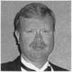

Donald B. Dennis, CPL has been dealing with the Locksmithing profession since 1972 with a four year apprenticeship in Albuquerque, New Mexico. He founded and has been the oivner of Dennis Safe & Lock in Johnson City, Tennessee since 1977. He was the founder of the East Tennessee Locksmith Association in 1988 and is currently the Chairman of the Education Committee and editor ofETLA Newsletter.

I Sal Dulcamaro,

CML, has been in the locksmith  
business for over 23 years. He is the  
president of All Pro Security, Inc. in  
Michigan and has been an ALOA  
member for 16 years. A past president  
of the Locksmith Security Association  
of Michigan. Sal currently serves as  
editor of the association newsletter. He  
was named Keynotes Author of the  
Year” for 1996 and 1997 and is  
currently a Contributing Editor.



Mike Emery is the

Editor of Keynotes and a freelance  
music, film, real estate and community  
events writer.



Mike Ferrill is a

third generation locksmith, who lives  
on the Island of Nantucket in Massa-  
chusetts.

El

HrVH Dan Graffeo is the president ofTimemaster, Inc. as well as a CRL and CMS. In 1996, he was the recipient of the ALOA Lifetime of Outstanding Achievement award.



Tim McMullen

oversees legislative affairs for ALOA.  
He is a graduate of the District of  
Columbia School of Law and has an  
extensive background in legislative

work.

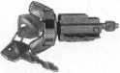

1999 Illustrated Automotive Parts Catalog

including BWD Distributors, VATS Centers, Seminar Schedule,  
Service Manual Library Centers, and more... call

**(800) 647-4926**

or take your web browser to [www.alllock.com](http://www.alllock.com).

\

BkA/D Automotive

Automotive Locks, Keys, Service Kits, Manuals & Training  
for the Professional Locksmith

DOMESTIC

Classic to Late Model

GM - Ford - Chrysler - Saturn

IMPORT

Honda - Nissan - Toyota  
Mitsubishi - Hyundai

INTERCHANGEABLE CORE PRODUCTS

Interchangeable

with:

•BEST

• ARROW W0*

•FALCON

Quality • Price Delivery

That's what KSP is all about!

KILLEEN SECURITY  
PRODUCTS

Ask your wholesaler about  
our drop shipping.

**CONTROL**

***33 Hermon St.  
Worcester, IUA 01610  
Phone (508) 798-3200  
Fax (508) 753-2183***

May 1999

Keynotes

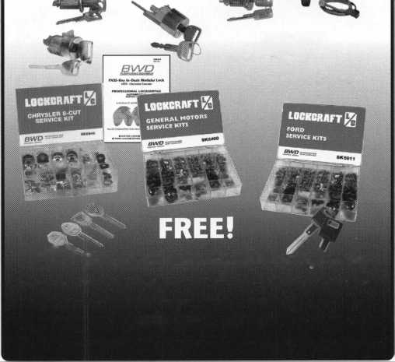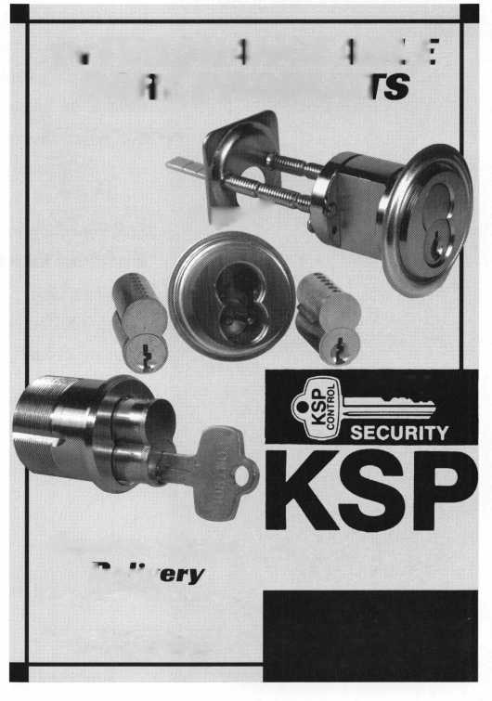

|  |  |  |
| --- | --- | --- |
| 1 Keynotes |  | May 199< |
| I | | |



Take Me  
Out To The  
Ball Game!

What do baseball and ALOA ’99 have in common?  
Well, both will be in Cincinnati this summer. With  
that, we’d like to send a lucky convention-goer to see  
the Reds take on the San Francisco Giants on July 30 .

If you love baseball, then you’ll want to visit  
Cinergy Field and experience the mania of Cincinnati

baseball. After all, this is the city that produced the famous ‘Big Red Machine’ and so  
many other notable teams.

If you have a baseball memory—such as your first ever pro game, little league experiences, getting a legend’s autograph, catching a homerun ball or anything that involves the game—jot it down on a piece of paper and either mail or fax it to us. We’ll draw a lucky winner who will receive two tickets to the Reds-Giants game, and publish some of the anecdotes in the following issue.

Send your entry to:

**Keynotes\*** Take Me Out To The Ball Game Contest!

3003 Live Oak Dallas, TX 75204 or fax to: 214.827.1810

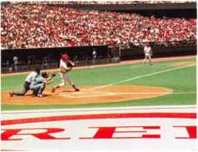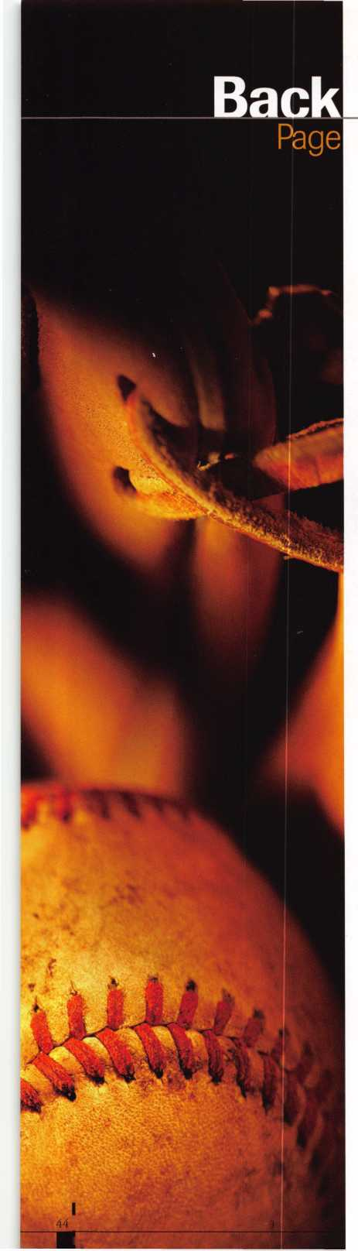

Wurri

i_j wca 15 Please u start 1 I extend mv subsi

J 3 YEARS (includes 36 issues, 3 FREE Annual Directory* issues)

USA $90.00

J 2 YEARS (includes 24 issues, 2 FREE Annual Directory* issues)

USA $64.00 Canada $93.00 International (air) $185.00

] 1 YEAR (includes 12 issues, 1 FREE Annual Directory* issue)

USA $41.00 Canada $52.00 International (air) $100.00

International (surface) $119.00

International (surface) $65.00

**the Security Professional**

' O DINING A WORLD Or OFTORTUNITILS

’Comprehensive guide to industry manufacturers, distributors, products and services.

**CARD INVALID UNLESS COMPLETE DATA IS GIVEN**

You must indicate your locksmithing affiliation below:

1. Are you a locksmith or an individual involved in locksmithing? Qyes Qno
2. Your position is: QOwner/Pres. Q3 Employee Q6 Student Q9 Other (specify)

3 Business classification (check one only): a □Locksmith Shop b QHardware c Q Wholesaler/Distributor d Q Manufacturer e Q Security or Maintenance

1Q Consultant 3 Q Industrial sQ Government

2 Q Commercial 4 Q Institutional 6 Q Police

g Q Architect/Specifier z Q Other (specify)

4. Are you involved in purchasing or influencing the purchase of locksmith products?

□yes Qno

Name:.

Company:. Address: _

City: _

. State:.

_Zip:_

Phone:.

.Fax: _

Payment (US FUNDS ONLY): □Money order □Charge Card □Check#:

Complete For Charge Orders Only: QVISA □Master Card QAmerican Express

Account # :Exp. Date:

Signature:

IM9

Send payment to: Locksmith Publishing Corp. • 850BusseHwy. • Park Ridge, IL 60068 • Phone:(847)692-5940 • Fax (847) 692-4604 • Website: [www.lpc.simon-net.com](http://www.lpc.simon-net.com)

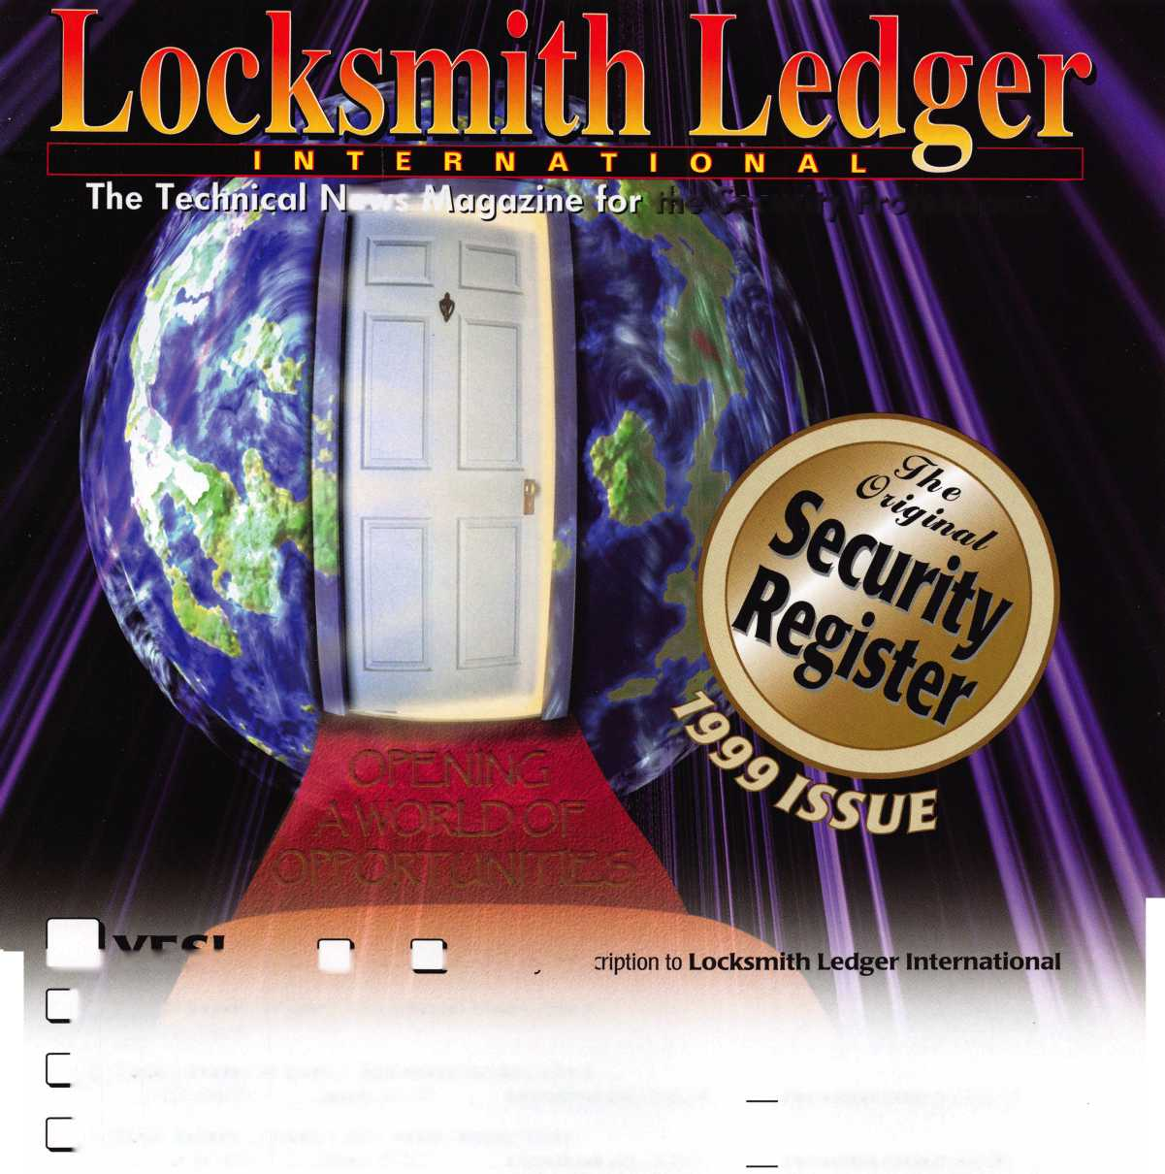

Into classes, into networking,  
into the latest products.

This year, don't miss the best  
locksmithing trade show and education  
event of 1999-the ALOA Convention  
and Security Expo. Discover the city  
that boasts Fountain Square, riverboats,  
water parks and a breathtaking  
river view from Mt. Adams.

See you at the pool (the talent pool).

For more info, call 800.532.2562  
or check out [www.aloa.org](http://www.aloa.org)

